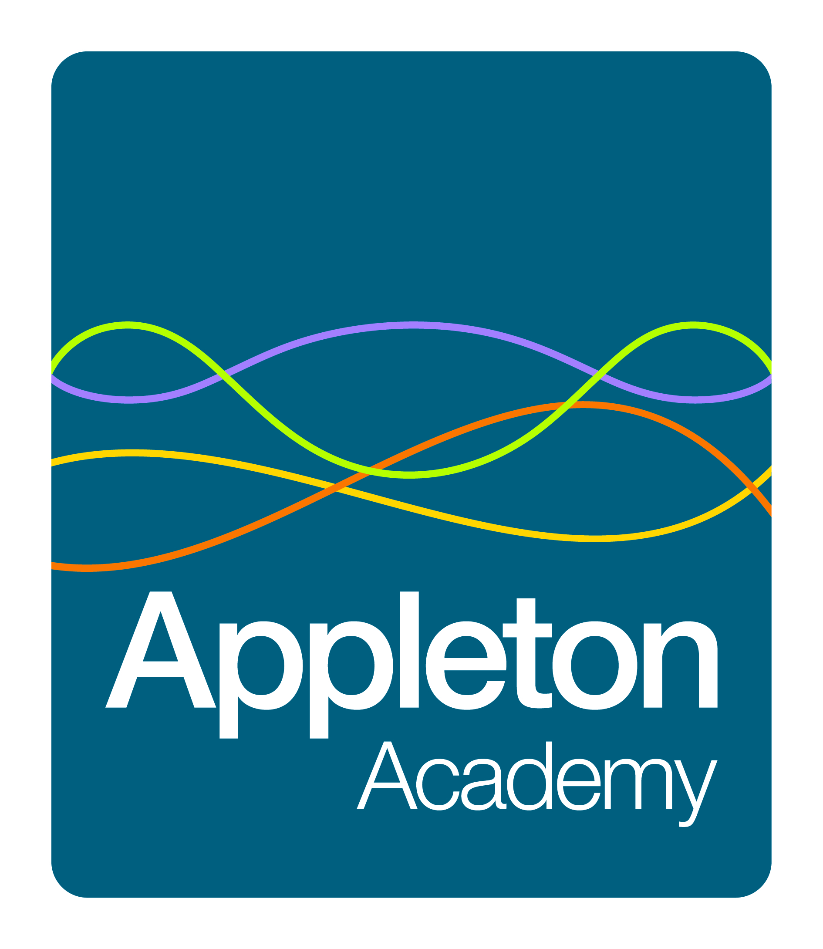
Aspiration and Achievement in Wyke

Outline Job Description
Lunchtime Assistant

Objectives

To ensure the supervision and safety of all our students from primary age to Year 11 throughout the official lunch period which currently has three sittings, under the direct supervision of the Senior Lunchtime Supervisor.

Range of Duties

- The supervision of students throughout the official lunch break
- Supervision and assistance where necessary of children in hand-washing areas
- Supervision of students waiting to enter the dining hall
- Supervision of students in the including managing positive behaviour in line with the academy behaviour policy
- To ensure the younger students have access to a drink of water with their meal or other appropriate drink provided by kitchen staff.
- To provide any necessary assistance to our younger students in respect of portion control, cutting up different food, supervising the scraping of plates, food containers and trays.
- To ensure that all students operate the self clearing system at tables
- To ensure that all dining and other areas are cleared at the end of the lunchtime period.
- Attending to the personal needs of students who are ill or have an accident during the lunch period, and clearing up after them.
- Ensuring that all minor accidents are reported and recorded in the academy accident booklet in line with academy policy.
- Ensuring that serious accidents are reported directly to the line manager, for action in line with academy policy.
- Ensure that instances of poor behaviour are managed effectively through the Academy’s behaviour management systems

General
All Academy staff are expected to:
- Work towards and support the Academy’s vision and the objectives
- Support and contribute to the Academy’s responsibility for safeguarding students
- Work within the Academy’s health and safety policy to ensure a safe working environment for staff, students and visitors
- Work within the Academy’s Equality Policies to promote equality of opportunity for all students and staff, both current and prospective
- Maintain high professional standards of attendance, punctuality, appearance, conduct and positive, courteous relations with students, parents and colleagues
- Engage actively in the performance review process where appropriate
- Adhere to Academy policies and procedures as set out in the staff handbook or other documentation available to all staff

This job description should be seen as enabling rather than restrictive and will be subject to regular review

