June 2020

Dear Parent/Carer

While the Academy was closed for half term a number of changes were made to Government guidelines regarding the extended opening of schools during the global Coronavirus pandemic. As a result there are a number of changes to our procedures that we will need to introduce from Wednesday 3 June 2020, which are aimed at ensuring the Academy is Covid Safe. Although some of these procedures will be very different to the way we usually operate, this is necessary to ensure the safety of our children, young people, families, staff and the wider community.

For those children accessing care provision, the following will be in place:

Arrival and Departure

- Parents will no longer be able to drive onto the site and the car park gates will remain closed at all times
- Children and young people will access school via the bottom pedestrian gate and leave via the top gate (near High Fernley Rd)
- Only parents of children in Reception, Year 1 and Year 2 will be allowed on site and will be expected to take their children to the drop off point at the central circle, which will be marked by a bollard and supervised by Academy staff - a member of staff will meet your child at this point and they will be taken to line up
- Parents will not be able to wait with their children and must leave site via the top pedestrian gate once their child has been dropped off with a member of staff
- The school office will remain closed to parents and you should call or email if you need to provide information to staff or if you have any queries
- Pupils in all other year groups must go to their designated entrance and line up at a social distance. Points will be marked out for pupils at a 2 metre distance. Children will know their group colour and where to go
- From Monday 8 June 2020, staff will take the temperature of each pupil on arrival using an infrared thermometer

If you do have to drive to school, please do not park in the permit parking spaces opposite the Academy site, these spaces are reserved for residents only.

Bubbles
From Wednesday 3 June 2020, your children will be allocated to a group of no more than 8 pupils, which will act as a ‘bubble’ to reduce the spread of infection:

- Each bubble will be allocated a colour and pupils in each bubble will only mix with those in their group
- The children in each bubble will spend their day together, spend social time with one another but will not be able to mix with children from another bubble
- In organising these groups, staff have tried to ensure the groups get on well with one another but children may not be with their normal social groups
- These groups cannot be changed once they have been set up and new pupils will not be able to join an existing bubble
- Children and young people must not bring their own resources, such as pens, pencil, books to school. These will be provided by the Academy to ensure that we can regularly clean them

Please make sure your child has a water bottle with them.

Social distancing must be strictly observed at all times. Children and young people who do not follow this expectation will be warned and their place in school could be at risk.

Coronavirus/COVID-19 Symptoms

- It is essential that if your child is experiencing COVID-19 symptoms that you call the NHS 111 or 119 help lines to arrange a test. Your child will need to self-isolate for 7 days. Family members within the household must self-isolate for 14 days.
- Where the child, young person or staff member tests positive, the rest of their bubble/group will be sent home and advised to self-isolate for 14 days. The Academy will be closed for 14 days for deep cleaning if we are informed that a child or member of staff has tested positive.

If you have any concerns or queries regarding these new procedures, please do not hesitate to contact us by phoning the main office on 01274 600550 or by emailing info@appletonacademy.co.uk.

Thank you for your continued support during these challenging times.

Yours faithfully
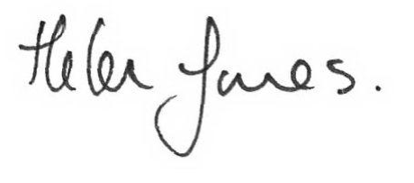

Ms H Jones
Executive Headteacher

