Timetable for Reception remote learning Spring 1 Weeks 1 and 2 Reception

Please find below the timetable for your child to complete during the school closure. The children can work through the lessons set each day which have a mixture of online learning and fun activities to do at home.
Day 1 | Subject | Activity
 | Literacy | To listen to and respond to a story ‘The gingerbread man’.  https://www.youtube.com/watch?v=pckuS--UlV4  Discuss the story and what happens. Who are the characters? What did they all want to do?  Can you remember what happened?  Retell the story in your own words.
 | Reading | What words can you see around your house? Can you try and read them? Say the sounds, put them together to read the word.  From the words you have found, which word do you like the best? Why?
 | Phonics | Learning the sound ch  Learn the action and song - https://www.youtube.com/watch?v=UiT2nd4GJJQ  Online video - https://www.youtube.com/watch?v=tuzFWRkKh8A  Learn to read words online - https://www.youtube.com/watch?v=U2mlqh3OVAk  Practise writing ch  Writing words - chin, chat, chop  Reading - ‘I can chop it up’.  Practice reading words – no, go, I, to, the
 | Maths | Starter/warm up: Counting to 10 and back again. Use fingers to count to 10 (put fingers up) and back from 10 (put fingers down)  Learning the different ways we can make 5  Using soft toys and a small box, throw the toys into the box and count how many lands inside the box and how many lands outside the box. Count altogether to check there is still 5.  Record your results onto some paper with columns labelled ‘in’ and ‘out’.  Number blocks number 1 - https://www.bbc.co.uk/iplayer/group/b08bzfnh
 | Theme | Complete a weather chart for the week. Monday – Friday.  Before you start, predict what you think the weather might be for each day and write it down.  For each day, write what the weather is like and draw a picture to match
 | PE | PE session with Joe Wicks  https://classroom.thenational.academy/pe/pe-with-joe-or-27th-april  Click on the link and complete the activity.

Day 2 | Subject | Activity
 | Literacy | To retell the story from memory of ‘The gingerbread man’  Please share this with your child over and over so they can become familiar with retelling the story and using the story language (Once upon a time, early one morning, so, but, next, finally, after that, lived happily ever after). You can discuss what they liked/disliked about the story.  Some comprehension questions you may like to ask around the story;  * Why did the gingerbread man run away?  *Who was chasing him?  *Why was the fox a sly fox?  This shows the story as a story map https://www.pinterest.co.uk/pin/327636941626002428/
 | Reading | Adult to draw some animals i.e. pig, hen, dog etc and write the matching words  Read the word and match it to the correct picture.
 | Phonics | Learning the sound sh  Learn the action and song - https://www.youtube.com/watch?v=3uyqR3u4jtg  Online video - https://www.youtube.com/watch?v=7fE27v8n7Vw  Learn to read words online - https://www.youtube.com/watch?v=xaTk1GRH29g  Practise writing sh.  Think of some objects that begin with the letters sh and ch. Draw the pictures to match i.e. ship, chip, shell, chat. Label each picture.  Reading – ‘The fish and chip shop is shut’.  Practice writing words – the, to  Practise reading words – he, she
 | Maths | Starter/warm up: Recognising numbers 1-10 using flashcard (numbers on pieces of paper)  Learning the different ways we can make 5  Using 5 building bricks, discover how many different ways you can make a model. How many bricks tall is it? How many bricks wide is it?  Have you used 5 altogether?  Number blocks number 2 - https://www.bbc.co.uk/iplayer/group/b08bzfnh
 | Theme | https://www.youtube.com/watch?v=wpriVIpxSFI  Draw with Rob – Snowman  Complete weather chart
 | PE | Oti Mabuse  https://www.youtube.com/watch?v=hIp15TCx9nw  Click on the link and complete the activity.

Day 3 | Subject | Activity
 | Literacy | To explore the story by creating your own story map .  Try to draw a story map together and write the names of the characters.  Can you remember the order of the people and animals?  Re read the story out loud and put actions for (Once upon a time, early one morning, so, but, next, finally, after that, lived happily ever after). Refer to sheet below  https://www.talk4writing.com/wp-content/uploads/2018/12/Key-Connective-Actions.pdf  Have a go at writing the beginning to the story together. ‘Once upon a time an old lady made a gingerbread man’.
 | Reading | Read your favourite story and find the part you like the best.  Draw a picture and talk about why you like this the best.  Add some words from the story book to match the part you chose.
 | Phonics | Learning the sound th  Learn the action and song - https://www.youtube.com/watch?v=TQYDbZ8gqow  Online video - https://www.youtube.com/watch?v=kLBtb1PFV_g  Learn to read words online - https://www.youtube.com/watch?v=kI4NZz1JbHE  Practise writing th  Reading words this, that, with, thank  Writing – ‘The moth is in the bath’.  Practice writing words – the, to  Practise reading words – he, she
 | Maths | Starter/warm up: singing a familiar number song ‘5 little speckled frogs’.  Learning the different ways we can make 5  Using 5 pebbles from the garden and a small bucket or tub (that you can’t see through), adult to drop a number of pebbles into the bucket/tub and child to count, i.e. 3. Child to work out how many more pebbles are left/not in the bucket/tub. Repeat with other numbers. Encourage the child to show 5 fingers to start and each time they hear a pebble drop, to put a finger down and then count how many fingers are left.  Number blocks number 3 - https://www.bbc.co.uk/iplayer/group/b08bzfnh
 | Theme | Learning about seasons watch and take a quiz  https://www.bbc.co.uk/bitesize/topics/zkvv4wx/articles/zcx3gk7  Talk about winter and what happens? Where do the animals go?  With your child, explore what the word ‘hibernate’ means?  Complete the weather chart
 | PE | https://classroom.thenational.academy/pe/pe-with-joe-or-28th-april  Click on the link and complete the activity.

Day 4 | Subject | Activity
 | Literacy | Sequencing The gingerbread man story  Draw and cut out some of the characters and main pictures in the story.  Write out name labels for the characters.  Put these in the correct order that they appear in the story.
 | Reading | https://www.starfall.com/h/holiday/gingerbread/?t=314300574  Starfall – create your own gingerbread man and read the words to a part of the story.  What sounds can you spot?  Are there any tricky words?
 | Phonics | Learning the sound ng  Learn the action and song - https://www.youtube.com/watch?v=xqPMJR2cLwI  Online video - https://www.youtube.com/watch?v=DgD6yCIO3pw  Learn to read words online - https://www.youtube.com/watch?v=eN6GmiiR_2s  Practise writing ng  Using letter cards (s,a,t,p,i,n,m,d,o,g,f,h,k,l,t,r) and a card with ng, give the child a word such as ‘ping’ or ‘sang’ and they are to make that word with the letters.  Practice writing words – the, to  Practise reading words – he, she
 | Maths | Starter/warm up: Shape hunt around your home  Learning the different ways we can make 5  Playing dominoes - only use the dominoes that in total make 5. If you don’t have any, they can be made with paper and dots.  Number blocks number 4 - https://www.bbc.co.uk/iplayer/group/b08bzfnh
 | Theme | Create a snowman. Kitchen roll tube, white paint and coloured paper to add detail  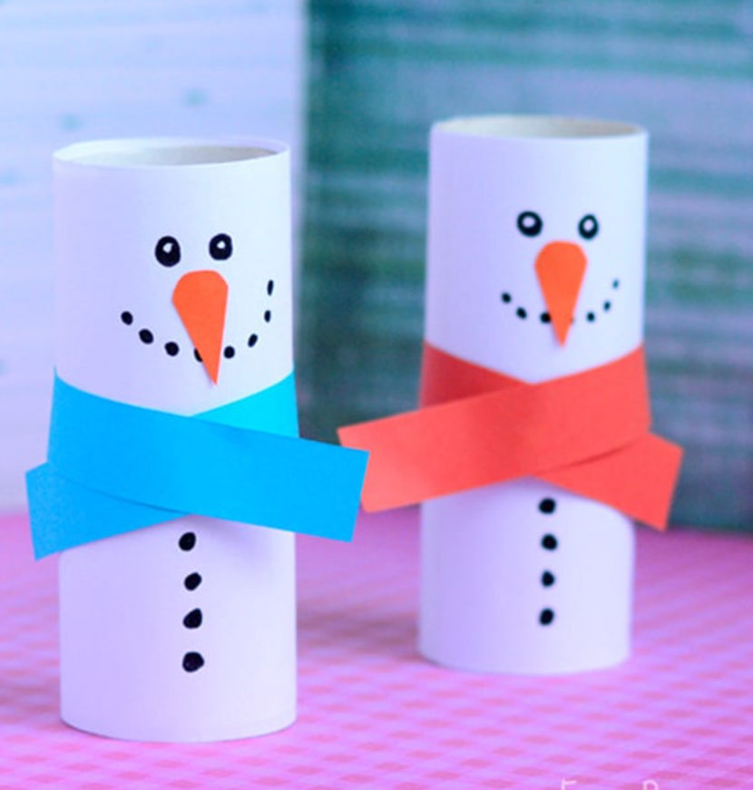  Complete the weather chart
 | PE | Oti Mabuse  https://www.youtube.com/watch?v=1QRmKit2NXw  Click on the link and complete the activity.

Day 5 | Subject | Activity
 | Literacy | Making your very own gingerbread man story  Using paper, create a book and draw the characters, use phonics knowledge to write words such as ‘run, run as fast as you can’.  Don’t forget to add some tricky words too – the, I, no, go, to
 | Reading | Practise reading words is, it, in, at  Can you find them in your favourite book
 | Phonics | Learning the sounds – ‘ai’  Online video - https://www.youtube.com/watch?v=siVkXoEQDNc  Learn the action and song - https://www.youtube.com/watch?v=_0lNTYRpNqU  Practise writing ai  Phonics game online - https://www.phonicsplay.co.uk/resources/phase/3/dragons-den  Writing words – rain, train, pain, main  Reading – ‘I am wet from the rain’  Practice writing words – the, to  Practise reading words – he, she, me, be, he
 | Maths | Starter/warm up: Estimation using time. Child to guess how long it will take them to run up the stairs and back, to do 10 star jumps.  Quick fire questions with number cards. Write the numbers 1,2,3,4,5 onto a piece of paper. Adult to show the child a number card and they have to work out how many more they need to make 5. Encourage them to use their fingers to try work it out.  Number blocks number 5 - https://www.bbc.co.uk/iplayer/group/b08bzfnh
 | Theme | Draw with Rob – Snow globe  https://www.youtube.com/watch?v=FeYJAGqmNs4  Complete the weather chart
 | PE | https://classroom.thenational.academy/pe/pe-with-joe-or-29th-april  Click on the link and complete the activity.

Day 6 | Subject | Activity
 | Literacy | Make puppets of the characters in the gingerbread man story.  Use these to act out the story. You could change the story by adding your own characters and sequence of events.  What happens in your story?  Who are the characters?
 | Reading | Adult to write out the letters of the alphabet on individual pieces of paper (lower case). Create as many 3 letter words as possible and time how many you can read in 1 minute.
 | Phonics | Learn the sound ee  Online video - https://www.youtube.com/watch?v=hBFFUCraDt8  Learn the song and action - https://www.youtube.com/watch?v=0_TiU-5dHpo  Practise writing ee  Balloon pop, have a number of balloons or pieces of paper and write on the letters we have learnt so far (ch, sh, th, ng, ai, ee) Adult to say a sound and child to pop the matching balloon or screw up the paper into a ball.  If using paper you can also play catch by making a ball and child to catch – can you say the sound?  Reading words – peek, heel, tree.  Writing – ‘I can jump from the tree’.  Practice writing words – the, to  Practise reading words – he, she, me, be, he
 | Maths | Starter/warm up: singing a familiar song ’10 green bottles’.  Mark/dot paper plates or pieces of paper with 1 – 5 and hang them up.  Can the children find a plate with 4 dots?  Can they find a plate with less/more dots?  Can they put the plates in order? Forwards and back?  Can they spot the missing plate?  Number blocks number 6 - https://www.bbc.co.uk/iplayer/group/b08bzfnh
 | Theme | Snowflakes. White and blue paper, cut out small squares and stick in the pattern of a snowflake.  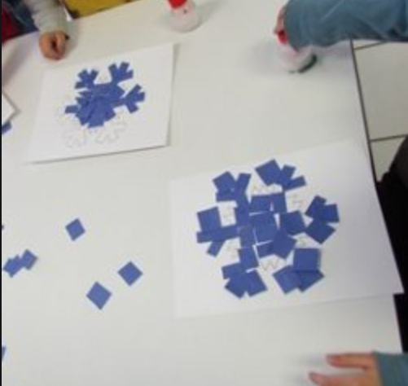
 | PE | https://classroom.thenational.academy/pe/pe-with-joe-or-27th-april  Click on the link and complete the activity.

Day 7 | Subject | Activity
 | Literacy | The runaway chapati  https://www.youtube.com/watch?v=NTzY1Hd_zJg  Listen to the story and compare it to the traditional tale of the gingerbread man.  What differences do you notice?  Are there some parts that are the same?  Does it have a repeated rhyme such as ‘run, run as fast as you can, you can’t catch me I’m the gingerbread man”.  Who are the main characters?
 | Reading | Practise reading words is, it, in, at  Tricky word hunt – hide words cards around the room and child to find them and read them to the adult.
 | Phonics | Learning the sound igh  Online video - https://www.youtube.com/watch?v=7anrdHnwGbs  Practise writing igh  Online game Phonics play Phonics pop - https://www.ictgames.com/phonicsPop/index.html  Writing words –high, sigh, fight, might  Reading – ‘The night is light’  Practice writing words – the, to  Practise reading words – he, she, me, be, he
 | Maths | Starter/warm up: Number spat – place number cards on the cupboards, shout a number and child splats it as quick as possible.  https://www.topmarks.co.uk/ordering-and-sequencing/caterpillar-ordering  Working with numbers to 10  Number blocks number 7 - https://www.bbc.co.uk/iplayer/group/b08bzfnh
 | Theme | Create a wintery story.  Draw snowy animals, a snowman and other characters you might want in your story.  Use your imagination to create a story in the winter time.
 | PE | Oti Mabuse  https://www.youtube.com/watch?v=SboNzLZea0o  Click on the link and complete the activity.

Day 8 | Subject | Activity
 | Literacy | The runaway chapati  https://www.youtube.com/watch?v=NTzY1Hd_zJg  Watch/listen to the story again.  From the discussion you had yesterday, write down some things that are different and some that are same. Use columns on a piece of paper with ‘different’ and ‘the same’ at the top.
 | Reading | Child to read a story to their adult. Choose a favourite book and child can read the story using their memory of the story and pictures to help.  Practise reading words is, it, in, at
 | Phonics | Learn the sound oa  Online video - https://www.youtube.com/watch?v=rrGadCz2A1o  Learn the song and action - https://www.youtube.com/watch?v=X7t60TYrvr8  Practise writing oa  Snowball – on pieces of paper, write the sounds j, v, w, y, qu, x, z, ch, sh, th, ng, ai, ee, igh, oa. Child to say the sounds on the paper then screw them all up and throw them into the middle of the room. Collect a snowball, open it and read the sound. You could time yourself to check how long it takes you to finish all the snowballs.  Reading words – load, soap, toad, loaf  Writing – ‘The goat is on the road’  Practice writing words – the, to  Practise reading words – he, she, me, be, he
 | Maths | Starter/warm up: One more/one less – adult to show an amount of fingers on one hand and child to show one more or one less.  Give children number cards with 1,2,3,4,5 on them. Adult to show the child an amount such as dots on piece of paper (up to 5).  Children are to try to recognise how many dots there are without counting. Using their numbers cards show a number that is the same as the dots, less than the dots and more than the dots.  Repeat using a different number of dots.  Number blocks number 8 - https://www.bbc.co.uk/iplayer/group/b08bzfnh
 | Theme | Make some play dough and gather some bits and bobs from around the house and garden. i.e, buttons, small twigs  Use these to create a wintery scene or snowy animal
 | PE | https://classroom.thenational.academy/pe/pe-with-joe-or-28th-april  Click on the link and complete the activity.

Day 9 | Subject | Activity
 | Literacy | Draw your favourite character from one of the stories.  Label the character highlighting the features i,e, body parts, clothing.  Now write a simple sentence to match your picture, i.e ‘the chapati is running fast’ or’ the fox wants to eat the gingerbread man’
 | Reading | Adult to write out the letters of the alphabet on individual pieces of paper (lower case). Create as many 3 letter words as possible and time how many you can read in 1 minute.  Can you read more words in 1 minute than last time?
 | Phonics | Learn the sound oo  Online video - https://www.youtube.com/watch?v=McxGM5mU0uM  Learn the song and action - https://www.youtube.com/watch?v=opQ7gMO9ysc  Practise writing oo  Using words from the reading and writing phonics activities from previous days, write a variety of them onto sheets of paper and place them on the floor. Sound talk a word (for example the word ‘moon’ you would say ‘m -oo -n’). Children are to blend the sounds and find the matching word. Begin with a few words only and add more words the more you play.  Writing words – book, look, cook / tool, moon, fool  Reading – ‘Look at the cook book’ / ‘Zoom into the moon’  Practice writing words – the, to  Practise reading words – he, she, me, be, he
 | Maths | Starter/warm up: I spy with shapes  https://www.topmarks.co.uk/learning-to-count/teddy-numbers  Teddy numbers - learning to recognise numbers to 10 and match the correct amount of objects to the numbers.  Number blocks number 9 - https://www.bbc.co.uk/iplayer/group/b08bzfnh
 | Theme | Draw with Rob  https://www.youtube.com/watch?v=I918viZORoU A fox
 | PE | Oti Mubuse  https://www.youtube.com/watch?v=EJmpCH9p2X8  Click on the link and complete the activity.

Basic play dough recipe
- 2 cups plain flour.
- 3/4 cup salt.
- 4 teaspoons cream of tartar.
- 2 cups lukewarm water.
- 2 Tablespoons of vegetable oil
- Food colouring, optional

