Spring Year 5 20th January – 2nd February
Timetable for Year 5 remote learning
Please find below the timetable for your child to complete during school time whilst they are not in school. Your child can work through the lessons set each day, and just follow the link which will take you straight to the teaching/learning for that lesson. They can record their work on the worksheets which have been sent home where appropriate or in their exercise books.

Day 1  Wed 20th Jan | Subject | Activity
 | Spellings | Creating nouns using -ship suffix  10 minutes ‘Look, Cover, Write, Check’ for the following words:  membership, ownership, partnership, dictatorship, championship
 | TTRS | 10 minutes TTRS practice  Your usernames are in your packs. If you lose it, please email your teacher: joanna.cross@appletonacademy.co.uk  https://ttrockstars.com/
 | English | Lesson 1 – To understand the features of a persuasive letter  https://classroom.thenational.academy/lessons/to-understand-the-features-of-a-persuasive-letter-74tk4d  Writing warm up  Write words in the correct word class categories – nouns, verbs, adjectives and adverbs  Main  What does ‘Persuasive’ mean? Read the text message and work out what persuasive means. Write the words persuade, persuasive, persuasion and persuading in the correct word class categories. When might you be persuasive in real life? What jobs require someone to use their persuasion skills?  Persuasive techniques - Flattery, Presumption, Veiled Threat  Can you persuade using the different persuasive techniques? Pause the lesson and think about how you can persuade someone to buy the pencil.  Features of a persuasive letter  Pause the lesson and read the letter, focus on the features (address, recipient, date, dear, opening, points of the letter, closing, ending, name).  Is a letter formal or informal?  Independent task  Write down all the features of a persuasive letter and then check your answers. Have you written them all down? Practise your persuasive techniques on your family.
 | Reading | Comprehension  Islamic Celebration: Eid Al-Fitr  Read the text and answer the questions
 | Writing | Creative Writing  Look at the picture on https://www.pobble365.com/.  Answer the questions and use this to inspire a piece of descriptive writing about the picture.
 | Maths | Lesson 11 – Divide 2 digits by 1 digit (2)  Watch the video and answer any questions in your exercise book  https://vimeo.com/492054019  Then, complete the worksheet titled ‘Divide 2 digits by 1 digit (2)’.  https://resources.whiterosemaths.com/wp-content/uploads/2019/11/Y4-Spring-Block-1-WO9-Divide-2-digits-by-1-digit-2-2019.pdf  Remember to check your answers:  https://resources.whiterosemaths.com/wp-content/uploads/2019/11/Y4-Spring-Block-1-ANS9-Divide-2-digits-by-1-digit-2-2019.pdf
 | Mental Maths | Mental Maths  Look at https://myminimaths.co.uk/year-5-week-3-multiplication-using-formal-written-methods-monday/  Answer the questions then check your answers on the page.
 | Art | You will need plain paper for this lesson.  Click on the link for Rob’s video.  Follow Rob’s instructions to create a similar drawing.  https://www.youtube.com/watch?v=dYE9voaB0IY
 | Computing | 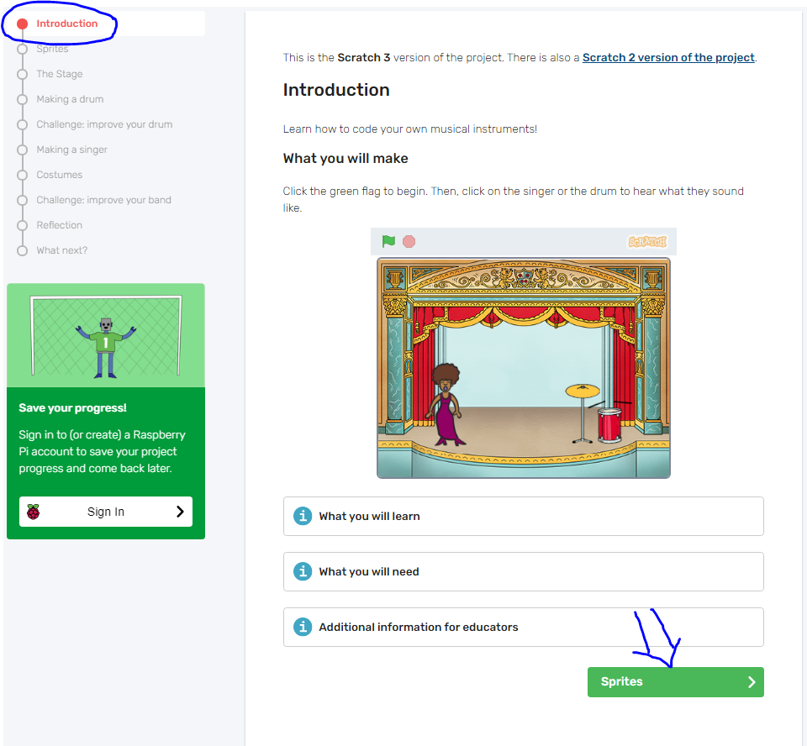  Learn how to code your own musical instruments  By completing this activity you will learn how to interact with sprites, change a sprite's costume, make use of user input and include sounds in your Scratch program.  Click on the web link below:  https://projects.raspberrypi.org/en/projects/rock-band  It will take you to the introductory page. To progress to the next part of the lesson, click the green button in the bottom right of the screen. You do not need to create an account to save your progress. However, if you would like to, you must have adult supervision or permission for this.  When you click on the sprites button (bottom right of the page), it will take you to an instruction page about making a new Scratch project. Open this website rpf.io/scratch-new in a new window and use the instructions to help you.  Once you have finished following the instructions on https://projects.raspberrypi.org/en/projects/rock-band/1, click on the green button in the bottom right of the screen called ‘the stage’.  There are step by step instructions on each screen. Follow them carefully and look at the diagrams that are show in each step as they will really help you.  If your computer or internet connection means you can’t access the program for whatever reason please don’t worry, just let your teacher know.  Have fun exploring the program and making a rock band! You can save your scratch program to your computer.
 | PE | Keeping physically active is important, to support your child with their daily activity they can choose to do an online video lesson or choose to do some other type of activity to help them to keep fit and healthy. We have provided a couple of suggestions below:  PE with Joe: https://www.youtube.com/watch?v=rAX6Q236CwI  https://peplanning.org.uk/downloads/pe-at-home/  This can be accessed, and the children can pick activities they would like to do. There are indoor and outdoor depending on the weather and space available.
 | Poetry | Click on the link to listen to the poem.  https://www.bbc.co.uk/bitesize/clips/z6cvr82  Activity:  Listen to the poem and tap out the beat as you listen.

 | Day 2  Thurs 21st Jan | Subject | Activity
 |  | Spellings | Creating nouns using -ship suffix  10 minutes ‘Look, Cover, Write, Check’ for the following words:  membership, ownership, partnership, dictatorship, championship
 |  | TTRS | 10 minutes TTRS practice  Your usernames are in your packs. If you lose it, please email your teacher: joanna.cross@appletonacademy.co.uk  https://ttrockstars.com/
 |  | English | Lesson 2 – To further investigate suffixes -ant, and -ent  https://classroom.thenational.academy/lessons/to-further-investigate-suffixes-ant-and-ent-c5jk4e  Why do we look at patterns and rules when studying spellings?  Key vocabulary  Recap the definitions of a noun, adjective, verb and suffix. Don’t forget to repeat the words after the teacher does. If you need to, jot down the definitions in your book. This might help you remember them.  Investigate  What is the same and what is different about the words… brilliant/recent;  Look at the suffix spelling rules for ‘ant’. Pause the video to write down any of the rules that are helpful.  How does adding the suffix ‘ant’ change the word class for the verbs? Pause the video where the teacher tells you.  How does adding the suffix ‘ant’ change the spelling and the word class of vacate? Pause the video where the teacher tells you to.  What is the correct spelling?  Pause the video and add the words to complete the sentence. Write the completed sentence down in your books.  Investigate the rules for the ‘ent’ suffix.  Can you spot a pattern for ‘ent’? Pause the video to make any notes when you need to. How does the suffix ‘ent’ change the word class of the word?  How are the sounds and patterns different between words ending with an ‘ent’ or ‘ant’ suffix?  Recap and review your learning from the lesson. Make notes using the diagrams shown on the video. Pause the video if you need to.  Complete the word map for ‘radiate’ having followed along with the teacher making a word map for ‘hesitate’.  Set Spellings  Write down the spellings to learn from this lesson. If you need to, write down the definitions or the spelling sentences to go with each word.  Recap on the spelling patterns and strategies for ‘ent’ and ‘ant’ suffixes.
 |  | Reading | Comprehension  Pentecost  Read the text and answer the questions
 |  | Writing | Creative Writing  Look at the picture on https://www.pobble365.com/.  Answer the questions and use this to inspire a piece of descriptive writing about the picture.
 |  | Maths | Lesson 12 – Divide 3 digits by 1 digit  Watch the video and answer any questions in your exercise book  https://vimeo.com/492054040  Then, complete the worksheet titled ‘Divide 3 digits by 1 digit’.  https://resources.whiterosemaths.com/wp-content/uploads/2020/06/Y4-Spring-Block-1-WO10-Divide-3-digits-by-1-digit-2019.pdf  Remember to check your answers:  https://resources.whiterosemaths.com/wp-content/uploads/2020/06/Y4-Spring-Block-1-ANS10-Divide-3-digits-by-1-digit-2019.pdf
 |  | Mental Maths | Mental Maths  Look at https://myminimaths.co.uk/year-5-week-3-multiplication-using-formal-written-methods-tuesday/  Answer the questions then check your answers on the page.
 |  | Art | You will need plain paper for this lesson.  Click on the link for Rob’s video.  Follow Rob’s instructions to create a similar drawing.  https://www.youtube.com/watch?v=hQR_HkQEUkI
 |  | History | What was life like for the Ancient Mayans?  Explore the information and activities on https://www.bbc.co.uk/bitesize/topics/zq6svcw/articles/zg2htv4.  Describe a day in the life of a Mayan person described in the video.  Record any interesting facts you have learned. You could do this by drawing a picture or a cartoon.
 |  | PE | Keeping physically active is important, to support your child with their daily activity they can choose to do an online video lesson or choose to do some other type of activity to help them to keep fit and healthy. We have provided a couple of suggestions below:  Dance with Oti: https://www.youtube.com/watch?v=y0RGGDusyKI&list=PLuwFE3Wyin9cSVFJ_Sjep0Pq6K1-e7sET&index=1  https://peplanning.org.uk/downloads/pe-at-home/  This can be accessed, and the children can pick activities they would like to do. There are indoor and outdoor depending on the weather and space available.
 |  | Poetry | Click on the link to the poem.  https://www.bbc.co.uk/bitesize/clips/z6cvr82  Activity:  Listen to the poem and write down five  sentences about what the dragon ate. You could use the starter ‘The dragon ate…….’

Day 3  Fri 22nd Jan | Subject | Activity
 | Spellings | Creating nouns using -ship suffix  10 minutes ‘Look, Cover, Write, Check’ for the following words:  craftsmanship, fellowship, apprenticeship, citizenship, sponsorship
 | TTRS | 10 minutes TTRS practice  Your usernames are in your packs. If you lose it, please email your teacher: joanna.cross@appletonacademy.co.uk  https://ttrockstars.com/
 | English | Lesson 3 – To explore pronouns  https://classroom.thenational.academy/lessons/to-explore-pronouns-75h38c  Writing warm-up  Complete the definitions using the words: noun, adverb, verb, adjective. Pause the video whilst you have a go then check your answers with the teacher. Can you spot a noun, adverb, verb or adjective in the sentence? Copy the sentence from the screen and highlight the words. Pause the video then check your answers with the teacher.  What are pronouns? Listen to the explanation. Pause the video if you need to and make notes that will help you remember. Copy the definition of pronouns into your book – use your best handwriting.  Identify the pronoun in each sentence. You might want to copy the sentences and underline the pronouns (for two or three sentences is fine).  Find out about the different classes of pronouns (don’t worry about making notes about this just yet).  Identify the pronouns in the sentences.  Independent Task  Pause the video to rewrite the sentences so that they use pronouns in the place of repeated nouns.
 | Reading | Comprehension  The Crash  Read the text and answer the questions
 | Writing | Creative Writing  Look at the picture on https://www.pobble365.com/.  Answer the questions and use this to inspire a piece of descriptive writing about the picture.
 | Maths | Lesson 13 – Divide 4 digits by 1 digit  Watch the video and answer any questions in your exercise book  https://vimeo.com/492054136  Then, complete the worksheet titled ‘Divide 4 digits by 1 digit’.  https://resources.whiterosemaths.com/wp-content/uploads/2019/11/Y5-Spring-Block-1-WO6-Divide-4-digits-by-1-digit-2019.pdf  Remember to check your answers:  https://resources.whiterosemaths.com/wp-content/uploads/2019/11/Y5-Spring-Block-1-ANS6-Divide-4-digits-by-1-digit-2019.pdf
 | Mental Maths | Mental Maths  Look at https://myminimaths.co.uk/year-5-week-3-multiplication-using-formal-written-methods-wednesday/  Answer the questions then check your answers on the page.
 | Art | You will need plain paper for this lesson.  Click on the link for Rob’s video.  Follow Rob’s instructions to create a similar drawing.  https://www.youtube.com/watch?v=GfbpU9Y6ltA
 | Science | Separating mixtures  What makes something pure?  In this lesson, we will learn what makes a substance pure or impure. We will also learn to draw diagrams to represent the particles in pure and impure substances. Complete the worksheet in your pack.  https://classroom.thenational.academy/lessons/what-makes-something-pure-crv3ge
 | PE | Keeping physically active is important, to support your child with their daily activity they can choose to do an online video lesson or choose to do some other type of activity to help them to keep fit and healthy. We have provided a couple of suggestions below:  PE with Joe: https://www.youtube.com/watch?v=Y2AkYD10d7Q  https://peplanning.org.uk/downloads/pe-at-home/  This can be accessed, and the children can pick activities they would like to do. There are indoor and outdoor depending on the weather and space available.
 | Poetry | Click on the link to listen to the poem.  https://www.bbc.co.uk/bitesize/clips/z6cvr82  Activity:  Listen to the poem. It is made up rhyming couplets. (two lines that rhyme) Make a list of pairs of words in the poem that rhyme.

Day 4  Mon 25th Jan | Subject | Activity
 | Spellings | Creating nouns using -ship suffix  Use each of the following words in a sentence (look up the words in a dictionary if you need to):  craftsmanship, fellowship, apprenticeship, citizenship, sponsorship
 | TTRS | 10 minutes TTRS practice  Your usernames are in your packs. If you lose it, please email your teacher: joanna.cross@appletonacademy.co.uk  https://ttrockstars.com/
 | English | Lesson 4 – To generate points to use in our persuasive letter  https://classroom.thenational.academy/lessons/to-generate-points-to-use-in-our-persuasive-letter-6muk2d  Warm up  Think about the different persuasive techniques we have found out about this week (flattery, presumption, veiled threat). Identify which definition fits which word (no need to write anything down unless you find making notes helpful – just follow along with the teacher in the video).  Make a note of what the word ‘mandatory’ means.  Do you agree or disagree with the statement? Why? Can you see both sides of the argument?  Why is school uniform a good thing?  Make a note under this heading in your book. Magpie the ideas from the teacher in your book. Pause the video if you want to add any more points.
 | Reading | Comprehension  On Your Bike (The article and questions go across both pages, so make sure you read both sides.)  Read the text and answer the questions
 | Writing | Creative Writing  Look at the picture on https://www.pobble365.com/.  Answer the questions and use this to inspire a piece of descriptive writing about the picture.
 | Maths | Lesson 14 – Divide with remainders  Watch the video and answer any questions in your exercise book  https://vimeo.com/492054148  Then, complete the worksheet titled ‘Divide with remainders’.  https://resources.whiterosemaths.com/wp-content/uploads/2019/11/Y5-Spring-Block-1-WO7-Divide-with-remainders-2019.pdf  Remember to check your answers:  https://resources.whiterosemaths.com/wp-content/uploads/2019/11/Y5-Spring-Block-1-ANS7-Divide-with-remainders-2019.pdf
 | Mental Maths | Mental Maths  Look at https://myminimaths.co.uk/year-5-week-3-multiplication-using-formal-written-methods-thursday/  Answer the questions then check your answers on the page.
 | Art | You will need plain paper for this lesson.  Click on the link for Rob’s video.  Follow Rob’s instructions to create a similar drawing.  https://www.youtube.com/watch?v=IrhnLase7L8
 | RE | What is Passover?  https://www.bbc.co.uk/bitesize/topics/znwhfg8/articles/zn22382  Passover is a celebration of the story of Exodus. During Passover, Jews remember how their ancestors left slavery behind them when they were led out of Egypt by Moses. Passover is celebrated with a series of rituals. Each ritual symbolises a different part of the story.  Explore the video and the activities on the web link.  Record what you have learned in your book.
 | PE | Keeping physically active is important, to support your child with their daily activity they can choose to do an online video lesson or choose to do some other type of activity to help them to keep fit and healthy. We have provided a couple of suggestions below:  Dance with Oti: https://www.youtube.com/watch?v=EJmpCH9p2X8&list=PLuwFE3Wyin9cSVFJ_Sjep0Pq6K1-e7sET&index=2  https://peplanning.org.uk/downloads/pe-at-home/  This can be accessed, and the children can pick activities they would like to do. There are indoor and outdoor depending on the weather and space available.
 | Poetry | Click on the link to listen to the poem.  https://www.bbc.co.uk/bitesize/clips/z6cvr82  Activity:  Listen to the poem. It contains a chorus. Try and recite the chorus.

Day 5  Tues 26th Jan | Subject | Activity
 | Spellings | Creating nouns using -ship suffix  Choose six of the following words to use in a sentence:  membership, ownership, partnership, dictatorship, championship, craftsmanship, fellowship, apprenticeship, citizenship, sponsorship
 | TTRS | 10 minutes TTRS practice  Your usernames are in your packs. If you lose it, please email your teacher: joanna.cross@appletonacademy.co.uk  https://ttrockstars.com/
 | English | Lesson 5 – To develop a rich understanding of words associated with feeling surprised  https://classroom.thenational.academy/lessons/to-develop-a-rich-understanding-of-words-associated-with-feeling-surprised-65jp2t  Key vocabulary – synonym, word pair, adjective, noun  New vocabulary  How might you look if you are really surprised?  What is happening in the picture? What is it showing? How would you describe how the character is feeling?  Flabbergasted – Which words are the synonyms for flabbergasted? What are the word pairs? What does flabbergasted mean?  Look at the picture, what is happening in the picture? What is it showing? How would you describe how the character is feeling?  Speechless – this word has a suffix, what does the suffix (less) mean?  Which words are the synonyms for speechless? What are the word pairs? What does speechless mean?  Look at the picture, what is happening in the picture? What is it showing? How would you describe how the character is feeling?  Stunned - Which words are the synonyms for stunned? What are the word pairs? What does stunned mean?  Apply vocabulary  Write down your own definition for each word – flabbergasted, speechless, stunned  Which words are the best fit for each sentence? Write your own sentences using these words. Use the sentence scaffolds to help you. Remember to think about what your persuasive letter is about.
 | Reading | Comprehension  William Shakespeare  Read the text and answer the questions
 | Writing | Creative Writing  Look at the picture on https://www.pobble365.com/.  Answer the questions and use this to inspire a piece of descriptive writing about the picture.
 | Maths | Lesson 1 – What is a fraction?  Watch the video and answer any questions in your exercise book  https://vimeo.com/498327271  Then, complete the worksheet titled ‘What is a fraction’.  https://resources.whiterosemaths.com/wp-content/uploads/2019/12/Y4-Spring-Block-3-WO1-What-is-a-fraction_-2019.pdf  Remember to check your answers:  https://resources.whiterosemaths.com/wp-content/uploads/2019/12/Y4-Spring-Block-3-ANS1-What-is-a-fraction_-2019.pdf
 | Mental Maths | Mental Maths  Look at https://myminimaths.co.uk/year-5-week-3-multiplication-using-formal-written-methods-friday/  Answer the questions then check your answers on the page.
 | Art | You will need plain paper for this lesson.  Click on the link for Rob’s video.  Follow Rob’s instructions to create a similar drawing.  https://www.youtube.com/watch?v=44R4Lm20igE
 | History | Mayan Art  Look at the PowerPoint about Mayan Art found here. Design a Mayan vase depicting an important event, using design ideas from the PowerPoint.
 | PE | Keeping physically active is important, to support your child with their daily activity they can choose to do an online video lesson or choose to do some other type of activity to help them to keep fit and healthy. We have provided a couple of suggestions below:  PE with Joe: https://www.youtube.com/watch?v=uKjcZ8mUr-M  https://peplanning.org.uk/downloads/pe-at-home/  This can be accessed, and the children can pick activities they would like to do. There are indoor and outdoor depending on the weather and space available.
 | Poetry | Click on the link to listen to the poem.  https://www.bbc.co.uk/bitesize/clips/z6cvr82  Activity:  Listen to the poem and imagine you are writing a newspaper report about the school -eating dragon. Write down the headline you would use.

Day 6  Wed 27th Jan | Subject | Activity
 | Spellings | Homophones & Near Homophones  10 minutes ‘Look, Cover, Write, Check’ for the following words:  stationary, stationery, steal, steel, wary
 | TTRS | 10 minutes TTRS practice  Your usernames are in your packs. If you lose it, please email your teacher: joanna.cross@appletonacademy.co.uk  https://ttrockstars.com/
 | English | Lesson 6 – To plan a persuasive letter  https://classroom.thenational.academy/lessons/to-plan-a-persuasive-letter-71hk4e  Warm up  Justify your opinion using because. Discuss the four topics using because. Make sure your opinions are good ones to persuade another person.  Structuring a persuasive point  Why do we need to structure and plan a point? Use P.E.P.S as your planning structure. P-Point, E- Explanation, P-Proof, S- Summary  Recap on last lesson – we discussed why a school uniform stops competition between pupils. Use the P.E.P.S structure to plan why children should have PE every day. Remember to use notes and not sentences. Put this into a P.E.P.S structure. Orally rehearse your argument – Say it out loud! Practise your argument over and over again.
 | Reading | Comprehension  The Great Plague  Read the text and answer the questions
 | Writing | Creative Writing  Look at the picture on https://www.pobble365.com/.  Answer the questions and use this to inspire a piece of descriptive writing about the picture.
 | Maths | Lesson 2 – Equivalent Fractions (recap)  Watch the video and answer any questions in your exercise book  https://vimeo.com/498327458  Then, complete the worksheet titled ‘Equivalent Fractions’.  https://resources.whiterosemaths.com/wp-content/uploads/2019/12/Y4-Spring-Block-3-WO2-Equivalent-fractions-1-2019.pdf  Remember to check your answers:  https://resources.whiterosemaths.com/wp-content/uploads/2019/12/Y4-Spring-Block-3-ANS2-Equivalent-fractions-1-2019.pdf
 | Mental Maths | Mental Maths  Look at https://myminimaths.co.uk/year-5-week-4-long-division-using-formal-written-methods-monday/  Answer the questions then check your answers on the page.
 | Art | You will need plain paper for this lesson.  Click on the link for Rob’s video.  Follow Rob’s instructions to create a similar drawing.  https://www.youtube.com/watch?v=cImUAS94Hdk
 | Computing | Learn how to repeat.  By completing this activity you will use Scratch to learn how to program your own animation including how to repeat instructions.  https://projects.raspberrypi.org/en/projects/lost-in-space  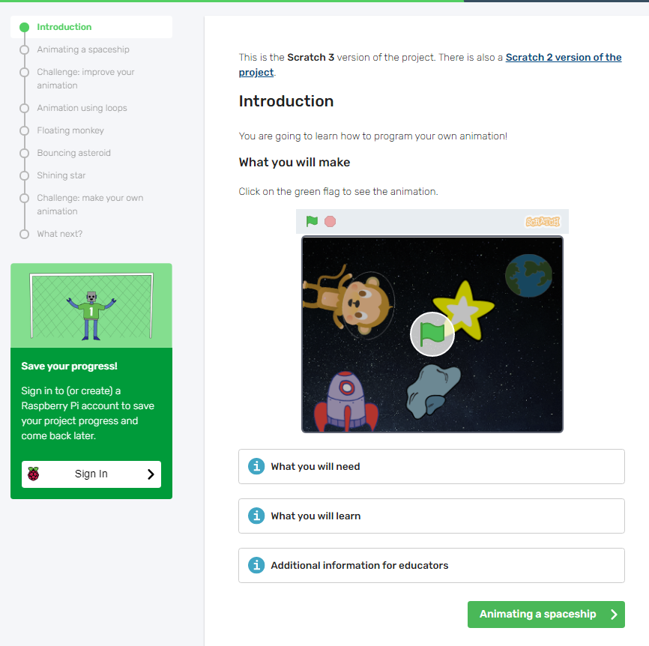  Similar to the last lesson, clicking this link will take you to a lesson page for you to follow step by step instructions.  Open rpf.io/scratch-new in a new window so that you can continue to follow the instructions on the lesson page.  If you need extra help (for example, on adding a new sprite to your page), click on the letter i in a blue circle where you will find extra information and instructions.  Click on the green button in the bottom right of the page to progress to the next part of the lesson.  If your computer or internet connection means you can’t access the program for whatever reason please don’t worry, just let your teacher know.  When you have finished, you can save your scratch program to your computer.
 | PE | Keeping physically active is important, to support your child with their daily activity they can choose to do an online video lesson or choose to do some other type of activity to help them to keep fit and healthy. We have provided a couple of suggestions below:  Dance with Oti: https://www.youtube.com/watch?v=GZuEnbSwOto&list=PLuwFE3Wyin9cSVFJ_Sjep0Pq6K1-e7sET&index=3  https://peplanning.org.uk/downloads/pe-at-home/  This can be accessed, and the children can pick activities they would like to do. There are indoor and outdoor depending on the weather and space available.
 | Poetry | Click on the link to listen to the poem.  https://childrens.poetryarchive.org/poem/at-the-pantomime/  Activity:  Listen to the poem and write down the name of your favourite pantomime and why.

Day 7  Thurs 28th Jan | Subject | Activity
 | Spellings | Homophones & Near Homophones  10 minutes ‘Look, Cover, Write, Check’ for the following words:  stationary, stationery, steal, steel, wary
 | TTRS | 10 minutes TTRS practice  Your usernames are in your packs. If you lose it, please email your teacher: joanna.cross@appletonacademy.co.uk  https://ttrockstars.com/
 | English | Lesson 7 – To practise and apply knowledge of suffixes -ant and -ent, including a test  https://classroom.thenational.academy/lessons/to-practise-and-apply-knowledge-suffixes-ant-and-ent-including-a-test-6cvk4d  Key vocabulary – Noun, adjective, Verb, Suffix  Spelling rules and patterns  What is the same and different about brilliant and recent? What happens with the suffix ‘ant’? Dominate – Dominant  What happens when the word changes from irritate to irritant?  Which suffix (ant or ent) is added to these root words? What is the pattern?  Look at the word map for the word hesitate.  Repeat the word map for the word radiate  Spelling practice  Jumble and order – Jumble the letters and put them back in the correct order. Have a go with the words – consonant, parliament, environment, frequent.  Take the spelling test!
 | Reading | Comprehension  Girls Can!  Read the text and answer the questions
 | Writing | Creative Writing  Look at the picture on https://www.pobble365.com/.  Answer the questions and use this to inspire a piece of descriptive writing about the picture.
 | Maths | Lesson 3 – Equivalent Fractions  Watch the video and answer any questions in your exercise book  https://vimeo.com/498327611  Then, complete the worksheet titled ‘Equivalent Fractions’  https://resources.whiterosemaths.com/wp-content/uploads/2019/12/Y5-Spring-Block-2-WO1-Equivalent-fractions-2019.pdf  Remember to check your answers:  https://resources.whiterosemaths.com/wp-content/uploads/2019/12/Y5-Spring-Block-2-ANS1-Equivalent-fractions-2019.pdf
 | Mental Maths | Mental Maths  Look at https://myminimaths.co.uk/year-5-week-4-long-division-using-formal-written-methods-tuesday/  Answer the questions then check your answers on the page.
 | Art | You will need plain paper for this lesson.  Click on the link for Rob’s video.  Follow Rob’s instructions to create a similar drawing.  https://www.youtube.com/watch?v=wpriVIpxSFI
 | History | What remains of the ancient Maya?  Explore the video and activities on https://www.bbc.co.uk/bitesize/topics/zq6svcw/articles/zs2ph39.  Why do you think the archaeological evidence found about the Mayas tells us about how they lived their lives? Explain your thoughts by writing them down in your book. Take a look at some of the fascinating ancient ruins from around the Maya world on the BBC clip at the end of the page.
 | PE | Keeping physically active is important, to support your child with their daily activity they can choose to do an online video lesson or choose to do some other type of activity to help them to keep fit and healthy. We have provided a couple of suggestions below:  PE with Joe: https://www.youtube.com/watch?v=g8X1pvW3Spg  https://peplanning.org.uk/downloads/pe-at-home/  This can be accessed, and the children can pick activities they would like to do. There are indoor and outdoor depending on the weather and space available.
 | Poetry | Click on the link to listen to the poem.  https://childrens.poetryarchive.org/poem/at-the-pantomime/  Activity:  Listen to the poem and list all the pantomimes referred to in the poem.

Day 8  Fri 29th Jan | Subject | Activity
 | Spellings | Homophones & Near Homophones  10 minutes ‘Look, Cover, Write, Check’ for the following words:  weary, who’s, whose, fate, fete
 | TTRS | 10 minutes TTRS practice  Your usernames are in your packs. If you lose it, please email your teacher: joanna.cross@appletonacademy.co.uk  https://ttrockstars.com/
 | English | Lesson 8 – To develop an understanding of how to use formal conjunctions  https://classroom.thenational.academy/lessons/to-develop-an-understanding-of-how-to-use-formal-conjunctions-cnjkac  Warm up  Sort out the different conjunctions into the two types – coordinating and subordinating.  Conditional formal conjunctions  Use the conditional formal conjunctions to continue the sentences.  Revise formal conjunctions  What is a conjunction? What is a formal conjunction? Read the passage and identify the formal conjunction – is it ‘and’ ‘but’ or ‘casual’ conjunction?  Practise using formal conjunctions  Use the correct formal conjunction in the gap  Independent task  Write three pairs of sentences and use a formal conjunction to link them together. Use the P.E.P.S plan from the previous lesson.
 | Reading | Comprehension  Usain Bolt  Read the text and answer the questions
 | Writing | Creative Writing  Look at the picture on https://www.pobble365.com/.  Answer the questions and use this to inspire a piece of descriptive writing about the picture.
 | Maths | Lesson 4 – Fractions greater than 1  Watch the video and answer any questions in your exercise book  https://vimeo.com/498362964  Then, complete the worksheet titled ‘Fractions greater than 1’.  https://resources.whiterosemaths.com/wp-content/uploads/2019/12/Y4-Spring-Block-3-WO4-Fractions-greater-than-1-2019.pdf  Remember to check your answers:  https://resources.whiterosemaths.com/wp-content/uploads/2019/12/Y4-Spring-Block-3-ANS4-Fractions-greater-than-1-2019.pdf
 | Mental Maths | Mental Maths  Look at https://myminimaths.co.uk/year-5-week-4-long-division-using-formal-written-methods-wednesday/  Answer the questions then check your answers on the page.
 | Art | You will need plain paper for this lesson.  Click on the link for Rob’s video.  Follow Rob’s instructions to create a similar drawing.  https://www.youtube.com/watch?v=x0O47h89KrY
 | Science | Separating mixtures  What makes something a mixture?  In this lesson, we will learn what makes a substance a mixture. We will also learn how to identify mixtures and the benefits of using an alloy over a pure metal.  https://classroom.thenational.academy/lessons/what-makes-something-a-mixture-61j38e  Click on the worksheets and answer the questions in your books
 | PE | Keeping physically active is important, to support your child with their daily activity they can choose to do an online video lesson or choose to do some other type of activity to help them to keep fit and healthy. We have provided a couple of suggestions below:  Dance with Oti: https://www.youtube.com/watch?v=hvfYzQgrXgk&list=PLuwFE3Wyin9cSVFJ_Sjep0Pq6K1-e7sET&index=4  https://peplanning.org.uk/downloads/pe-at-home/  This can be accessed, and the children can pick activities they would like to do. There are indoor and outdoor depending on the weather and space available.
 | Poetry | Click on the link to listen to the poem.  https://childrens.poetryarchive.org/poem/at-the-pantomime/  Activity:  Listen to the poem and find pairs of words that rhyme.

Day 9  Mon 1st Feb | Subject | Activity
 | Spellings | Homophones & Near Homophones  Use each of the following words in a sentence (use a dictionary if you need to):  weary, who’s, whose, fate, fete
 | TTRS | 10 minutes TTRS practice  Your usernames are in your packs. If you lose it, please email your teacher: joanna.cross@appletonacademy.co.uk  https://ttrockstars.com/
 | English | Lesson 9 – To write a persuasive letter  https://classroom.thenational.academy/lessons/to-write-a-persuasive-letter-ccw68r  Layout of a persuasive letter  Label each part of the persuasive letter.  Writing the opening and point 1.  Writing point 2 and the closing.  Use the P.E.P.S planning structure and the success criteria for the persuasive letter. Try and tick of all the parts of the success criteria in your letter to the Education Secretary.
 | Reading | Comprehension  VE Day  Read the text and answer the questions
 | Writing | Creative Writing  Look at the picture on https://www.pobble365.com/.  Answer the questions and use this to inspire a piece of descriptive writing about the picture.
 | Maths | Lesson 5 – Improper fractions to mixed numbers  Watch the video and answer any questions in your exercise book  https://vimeo.com/498991812  Then, complete the worksheet titled ‘Improper fractions to mixed numbers’.  https://resources.whiterosemaths.com/wp-content/uploads/2019/12/Y5-Spring-Block-2-WO2-Improper-to-mixed-numbers-2019.pdf  Remember to check your answers:  https://resources.whiterosemaths.com/wp-content/uploads/2020/08/Y5-Spring-Block-2-ANS2-Improper-to-mixed-numbers-2019.pdf
 | Mental Maths | Mental Maths  Look at https://myminimaths.co.uk/year-5-week-4-long-division-using-formal-written-methods-thursday/  Answer the questions then check your answers on the page.
 | Art | You will need plain paper for this lesson.  Click on the link for Rob’s video.  Follow Rob’s instructions to create a similar drawing.  https://www.youtube.com/watch?v=CIKY8IzM1Is
 | RE | What is Yom Kippur?  https://www.bbc.co.uk/bitesize/topics/znwhfg8/articles/z4vvjhv  Yom Kippur means Day of Atonement. It is the most sacred and solemn day in the Jewish calendar.  Yom Kippur is a day to reflect on the past year and ask God's forgiveness for any sins. Jews do not work or go to school on this day.  Explore the video and the activities on the web link.  Record what you have learned in your book.
 | PE | Keeping physically active is important, to support your child with their daily activity they can choose to do an online video lesson or choose to do some other type of activity to help them to keep fit and healthy. We have provided a couple of suggestions below:  PE with Joe: https://www.youtube.com/watch?v=Y_SYhZ269HE  https://peplanning.org.uk/downloads/pe-at-home/  This can be accessed, and the children can pick activities they would like to do. There are indoor and outdoor depending on the weather and space available.
 | Poetry | Click on the link to listen to the poem.  https://childrens.poetryarchive.org/poem/at-the-pantomime/  Activity:  Listen to the poem and try and name all of the seven dwarfs.

Day 10  Tues 2nd Feb | Subject | Activity
 | Spellings | Homophones & Near Homophones  Choose six of the following words to write in a sentence:  stationary, stationery, steal, steel, wary, weary, who’s, whose, fate, fete
 | TTRS | 10 minutes TTRS practice  Your usernames are in your packs. If you lose it, please email your teacher: joanna.cross@appletonacademy.co.uk  https://ttrockstars.com/
 | English | Lesson 10 – To write a persuasive letter (free write)  https://classroom.thenational.academy/lessons/to-write-a-persuasive-letter-free-write-6rrk4r  Persuasive techniques  What are the 3 persuasive techniques? Write 3 sentences using the persuasive techniques to persuade the Prime minister to pass a law where all children receive £10 pocket money a week from the government.  Choosing a purpose  Use PALLP – Purpose, Audience, Language, Layout, Punctuation  What do you want to change?  Think about where you want to change?  Think about what you want to change?  Decide who you are going to write to?  Now generate the points for your persuasive letter and choose 2 important points. Use the P.E.P.S structure to plan your letter. Use the success criteria when writing your letter. Try to go above and beyond!
 | Reading | Comprehension  One Moment in Summer  Read the text and answer the questions
 | Writing | Creative Writing  Look at the picture on https://www.pobble365.com/.  Answer the questions and use this to inspire a piece of descriptive writing about the picture.
 | Maths | Lesson 6 – Mixed numbers to improper fractions  Watch the video and answer any questions in your exercise book  Then, complete the worksheet titled ‘Mixed numbers to improper fractions’.  https://resources.whiterosemaths.com/wp-content/uploads/2019/12/Y5-Spring-Block-2-WO3-Mixed-numbers-to-improper-fractions-2019.pdf  Remember to check your answers:  https://resources.whiterosemaths.com/wp-content/uploads/2020/01/Y5-Spring-Block-2-ANS3-Mixed-numbers-to-improper-fractions-2019.pdf
 | Mental Maths | Mental Maths  Look at https://myminimaths.co.uk/year-5-week-4-long-division-using-formal-written-methods-friday/  Answer the questions then check your answers on the page.
 | Art | You will need plain paper for this lesson.  Click on the link for Rob’s video.  Follow Rob’s instructions to create a similar drawing.  https://www.youtube.com/watch?v=MilR2D3cJRY
 | History | What happened to the Ancient Mayans?  People often think that the Mayas only existed in the past. Today there are over seven million Maya people, most of whom live in Central America and southern Mexico.  Find out about the Ancient Mayans and compare them to Mayans today using the activities and video on https://www.bbc.co.uk/bitesize/topics/zq6svcw/articles/zndq7p3. How are their lives different? How are they the same? Write or draw what you have found out in your book.
 | PE | Keeping physically active is important, to support your child with their daily activity they can choose to do an online video lesson or choose to do some other type of activity to help them to keep fit and healthy. We have provided a couple of suggestions below:  Dance with Oti: https://www.youtube.com/watch?v=dh97m6-PKRM&list=PLuwFE3Wyin9cSVFJ_Sjep0Pq6K1-e7sET&index=5  https://peplanning.org.uk/downloads/pe-at-home/  This can be accessed, and the children can pick activities they would like to do. There are indoor and outdoor depending on the weather and space available.
 | Poetry | Click on the link and listen to the poem.  https://childrens.poetryarchive.org/poem/at-the-pantomime/  Activity:  Listen to the poem and draw your favourite pantomime character.

