Timetable for Year 4 remote learning
Please find below the timetable for your child to complete during school time whilst they are not in school. Your child can work through the lessons set each day, and just follow the link which will take you straight to the teaching/learning for that lesson. Your child can record their work on the worksheets which have been sent home where appropriate or in their exercise books.
Mon 22nd  Feb | Subject | Activity
 | Spellings | 10 minutes ‘Look, Cover, Write, Check’ for the following 5 words:  Words with the /s/ sound spelt with ‘sc’  science  crescent  discipline  fascinate  scent
 | TTRS | 10 minutes TTRS practice  Please email dominic.firth@appletonacademy.co.uk if you can’t remember your username  https://ttrockstars.com/
 | English | Lesson 1  Lesson objective: To analyse the film clip and the story. Watch the link below and answer the following questions.  https://classroom.thenational.academy/lessons/to-analyse-a-film-clip-and-order-the-story-68tkct  Watch the video and answer the questions in your exercise books.  Write down everything you see in the picture – remember to be descriptive.  What word class are the blue and pink words?  What are the differences about the circled words?  Where does the video take place?  Who is in the story?  What happens in the story?  Give the following statements a true or false answer.  The main character is a robin?  The robins journey is easy?  The robin ends in a different place from where he started.  Watch the video and answer the questions in your exercise books.  What landscapes did the robin fly over?  How would you describe these landscapes?  Write one sentence about each picture from the clip.
 | Reading | Comprehension- Anne Frank  Read the text and answer the questions on the 2do ‘Anne Frank’ on purple mash. Remember to save your work.
 | Writing | Creative writing  Look at the picture on https://www.pobble365.com/.  Answer the questions and use this to inspire a piece of descriptive writing about the picture.
 | Maths | Lesson 1  Add two or more fractions  https://vimeo.com/507468794  Watch the video and answer any questions in your exercise book.  Then, complete the worksheet with the correct title. https://resources.whiterosemaths.com/wp-content/uploads/2020/01/Y4-Spring-Block-3-WO6-Add-2-or-more-fractions-2019-1.pdf  Remember to check your answers.  https://resources.whiterosemaths.com/wp-content/uploads/2020/08/Y4-Spring-Block-3-ANS6-Add-2-or-more-fractions-2019.pdf
 | Mental maths | Mental Maths  Look at https://myminimaths.co.uk/year-4-week-7-recognise-any-given-digit-in-a-4-digit-number-monday/  Answer the questions and you can check your answers on this page too.
 | Geography | What is a rainforest?  Click on the link below and watch the video about rainforests. Then, create a poster about rainforests using the facts you have learnt from your research. Try to answer the following questions as part of the poster. What is a rainforest? What lives in a rainforest? Where are rainforests found? Why do we need rainforests? Pick 5 facts about a rainforest to include in your poster.  https://www.youtube.com/watch?v=BO4UYhhU-8c
 | Art | Follow the link below for your drawing today:  Croissant:  https://www.youtube.com/watch?v=_IUF1Kyy5io  You will need a pencil and some paper.
 | PE | PE with Joe:  Keeping physically active is important, to support your child with their daily activity they can choose to do an online video lesson or choose to do some other type of activity to help them to keep fit and healthy. We have provided a couple of suggestions below: https://www.youtube.com/watch?v=tSi2ix1i180  https://peplanning.org.uk/downloads/pe-at-home/  This can be accessed, and the children can pick activities they would like to do. There are indoor and outdoor depending on the weather and space available.
 | Poetry | Click on the link and listen to the poem.  https://childrens.poetryarchive.org/poem  /wanted-wizards-assistant/  This poem contains lots of alliteration.(repetition of consonants)  Try and spot some examples of alliteration.
Tues  23rd  Feb | Subject | Activity
 | Spellings | Practise the words from yesterday and use them in sentence. Log in to purple mash and complete the 2do ‘Spellings week 1’  science  crescent  discipline  fascinate  scent
 | TTRS | 10 minutes TTRS practice  Please email dominic.firth@appletonacademy.co.uk if you can’t remember your username  https://ttrockstars.com/
 | English | Lesson 2  Learning objective: To explore complex sentences. Watch the link below and answer the following questions.  https://classroom.thenational.academy/lessons/to-explore-complex-sentences-68wp8c  Watch the video and answer the questions in your exercise books.  How many pieces of punctuation would you use if you wrote an adverbial complex sentence starting with as?  Is the sentence a main clause or a subordinate clause?  Complete the true or false statements in your exercise books.  Complex sentences have two different types of clause?  Complex sentences need to have more than 20 words in them?  Complete the task into your exercise books.
 | Reading | Comprehension- Ash Wednesday  Read the text and answer the questions.
 | Writing | Creative writing  Look at the picture on https://www.pobble365.com/.  Answer the questions and use this to inspire a piece of descriptive writing about the picture.
 | Maths | Lesson 2  Subtract fractions  https://vimeo.com/507527822  Watch the video and answer any questions in your exercise book.  Then, complete the worksheet with the correct title. https://resources.whiterosemaths.com/wp-content/uploads/2020/03/Y3-Summer-Block-1-WO7-Subtract-fractions-2020.pdf  Remember to check your answers.  https://resources.whiterosemaths.com/wp-content/uploads/2020/03/Y3-Summer-Block-1-ANS7-Subtract-fractions-2020.pdf
 | Mental maths | Mental Maths  Look at https://myminimaths.co.uk/year-4-week-7-recognise-any-given-digit-in-a-4-digit-number-tuesday/  Answer the questions and you can check your answers on this page too.
 | RE | What is Easter?  Click the link and watch the clip about easter. Then, read the description of the key events of Easter and complete the sorting activity at the end. When you have got the correct order, write down the correct order in your exercise book with descriptions.  https://www.bbc.co.uk/bitesize/topics/ztkxpv4/articles/z4t6rj6
 | Art | Follow the link below for your drawing today:  Chocolate Cake:  https://www.youtube.com/watch?v=7zC0kge5Sgg  You will need a pencil and some paper.
 | PE | PE with Joe:  Keeping physically active is important, to support your child with their daily activity they can choose to do an online video lesson or choose to do some other type of activity to help them to keep fit and healthy. We have provided a couple of suggestions below: https://www.youtube.com/watch?v=hnOtrnh80hs  https://peplanning.org.uk/downloads/pe-at-home/  This can be accessed, and the children can pick activities they would like to do. There are indoor and outdoor depending on the weather and space available.
 | Poetry | Click on the link and listen to the poem.  https://childrens.poetryarchive.org/poem/wanted-wizards-assistant/  Talk to an adult about a job you would like to do.
Wed  24th  Feb | Subject | Activity
 | Spellings | 10 minutes ‘Look, Cover, Write, Check’ for the following 5 words:  scissors  ascent  descent  scientist  scenery
 | TTRS | 10 minutes TTRS practice  Please email dominic.firth@appletonacademy.co.uk if you can’t remember your username  https://ttrockstars.com/
 | English | Lesson 3  Lesson objective: To generate vocabulary to describe settings and characters. Watch the link below and answer the following questions.  https://classroom.thenational.academy/lessons/to-generate-vocabulary-ccwk2t  Watch the video and answer the questions in your exercise books.  What word class are the pink words?  What word class are the blue words?  What’s different about the words that are circled?  What characters are there in the story?  How could we refer to them?  What parts of the story does the robin appear in?  Summarise what he does in the story.  Repeat for all the characters in the story – the female robin, the fisherman and the hawk.  Watch the video and answer the questions in your exercise books.  What adjectives could we use to describe the fisherman?  Which vocabulary boxes match the picture?
 | Reading | Comprehension- Boudicca  Read the text and answer the questions.
 | Writing | Creative writing  Look at the picture on https://www.pobble365.com/.  Answer the questions and use this to inspire a piece of descriptive writing about the picture.
 | Maths | Lesson 3  Subtract 2 fractions  https://vimeo.com/507597199  Watch the video and answer any questions in your exercise book.  Then, complete the worksheet with the correct title. https://resources.whiterosemaths.com/wp-content/uploads/2019/12/Y4-Spring-Block-3-WO7-Subtract-2-fractions-2019.pdf  Remember to check your answers.  https://resources.whiterosemaths.com/wp-content/uploads/2019/12/Y4-Spring-Block-3-ANS7-Subtract-2-fractions-2019.pdf
 | Mental maths | Mental Maths  Look at https://myminimaths.co.uk/year-4-week-7-recognise-any-given-digit-in-a-4-digit-number-wednesday/  Answer the questions and you can check your answers on this page too.
 | Science | What is an ecosystem?  Click on the link and watch the video. What do animals need to live? Stop the video and write your answers. Continue the video. What animals live in a rainforest? Stop the video and write down your answers. Continue the video.  Activity: Stop the video and write down all the animals, habitats, plants and microorganisms you noticed from the picture.  Then, continue the video to the final task: To match up the words with the definitions. Write them down in your exercise books  https://classroom.thenational.academy/lessons/what-is-an-ecosystem-cgtpcr?step=1&activity=video
 | Art | Follow the link below for your drawing today:  Cheese Puffs:  https://www.youtube.com/watch?v=rfjbcHYWqUo  You will need a pencil and some paper.
 | PE | PE with Joe:  Keeping physically active is important, to support your child with their daily activity they can choose to do an online video lesson or choose to do some other type of activity to help them to keep fit and healthy. We have provided a couple of suggestions below:  https://www.youtube.com/watch?v=l0k6XqfFEUo  https://peplanning.org.uk/downloads/pe-at-home/  This can be accessed, and the children can pick activities they would like to do. There are indoor and outdoor depending on the weather and space available.
 | Poetry | Click on the link and listen to the poem.  https://childrens.poetryarchive.org/poem/wanted-wizards-assistant/  Draw a picture of a wizard.
Thurs  25th  Feb | Subject | Activity
 | Spellings | Practise the words from yesterday and use them in sentence. Record the sentences in your book.  scissors  ascent  descent  scientist  scenery
 | TTRS | 10 minutes TTRS practice  Please email dominic.firth@appletonacademy.co.uk if you can’t remember your username  https://ttrockstars.com/
 | English | Lesson 4  Lesson objective: To identify word pairs and synonyms associated with the countryside then apply them into sentences. Watch the link below and answer the following questions.  https://classroom.thenational.academy/lessons/to-develop-a-rich-understanding-of-words-associated-with-the-countryside-part-1-75hk0e  Watch the video and answer the questions in your exercise books.  What is the most beautiful nature you have ever seen?  What is happening in the picture?  Which words are synonyms for rolling?  What does rolling mean?  What is happening in this picture?  Which words are synonyms for lush?  What does lush mean?  What is happening in this picture?  Which words are synonyms for idyllic?  What does idyllic mean?  Which words best suit the sentences?
 | Reading | Comprehension- Joe Biden  Read the text and answer the questions.
 | Writing | Creative writing  Look at the picture on https://www.pobble365.com/.  Answer the questions and use this to inspire a piece of descriptive writing about the picture.
 | Maths | Lesson 4  Subtract from whole amounts  https://vimeo.com/508878193  Watch the video and answer any questions in your exercise book.  Then, complete the worksheet with the correct title. https://resources.whiterosemaths.com/wp-content/uploads/2019/12/Y4-Spring-Block-3-WO8-Subtract-from-whole-amounts-2019.pdf  Remember to check your answers.  https://resources.whiterosemaths.com/wp-content/uploads/2019/12/Y4-Spring-Block-3-ANS8-Subtract-from-whole-amounts-2019.pdf
 | Mental maths | Mental Maths  Look at https://myminimaths.co.uk/year-4-week-7-recognise-any-given-digit-in-a-4-digit-number-thursday/  Answer the questions and you can check your answers on this page too.
 | ICT | Spreadsheets lesson 1  Log in to Purple mash and go to 2dos and launch spelling competition. In today's lesson, we will figure out each child's percentage using the calculator on the spreadsheet.  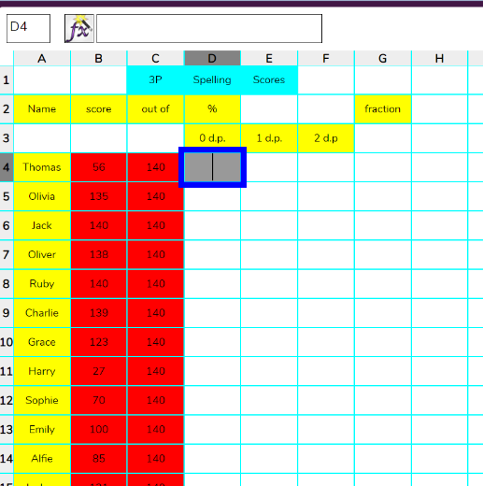  Then, click on the box next to Thomas score (D4) and then select the percentage button below.  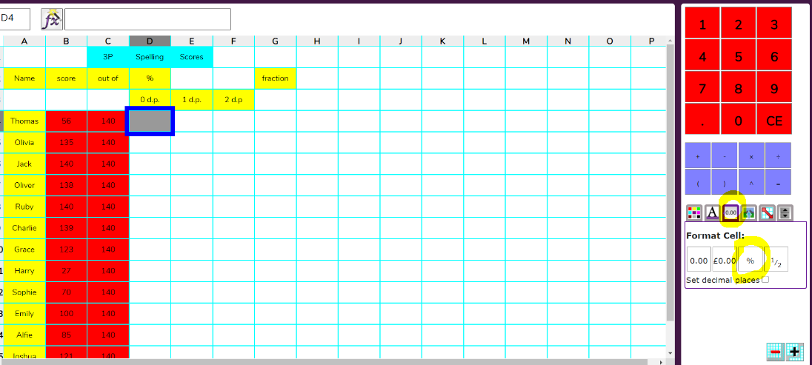  Then, click on the fx symbol at the top to tell the spreadsheet how to work out the percentage.  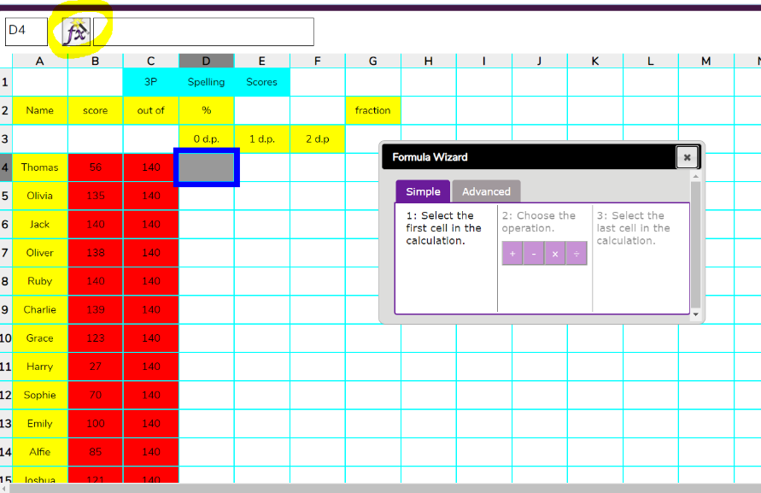  Then, click on Thomas’s score 56 in box B4. Then click the division icon and then the ‘out of’ in box C4, then click OK.  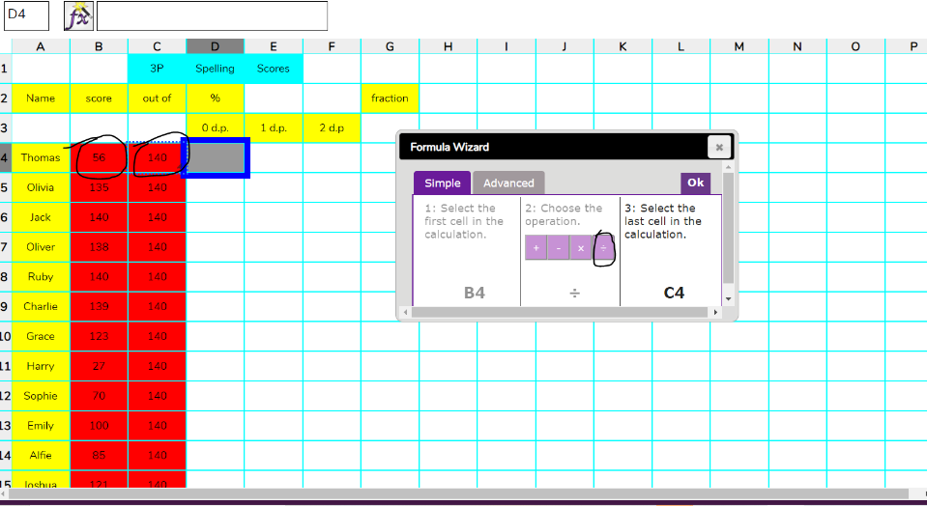  If you have done this correctly, it should say 40% now in Thomas’s percentage box.  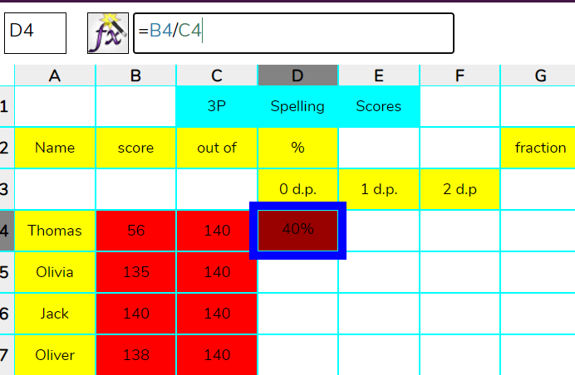  Now you can repeat this method to find the rest of the children’s percentages. Save your work when you have finished. The link below gives you further instruction if you're stuck.  https://static.purplemash.com/mashcontent/applications/schemes_of_work/computing_schemes_of_work/computing_sow_year4_unit_4_3/Unit%204.3%20Spreadsheets.pdf
 | Art | Follow the link below for your drawing today:  Alice in Wonderland:  https://www.youtube.com/watch?v=RL8UxORQwZc  You will need a pencil and some paper.
 | PE | PE with Joe:  Keeping physically active is important, to support your child with their daily activity they can choose to do an online video lesson or choose to do some other type of activity to help them to keep fit and healthy. We have provided a couple of suggestions below:  https://www.youtube.com/watch?v=xs_g2B-D7zg  https://peplanning.org.uk/downloads/pe-at-home/  This can be accessed, and the children can pick activities they would like to do. There are indoor and outdoor depending on the weather and space available.
 | Poetry | Click on the link and listen to the poem.  https://childrens.poetryarchive.org/poem/wanted-wizards-assistant/  Try and remember some of the jobs a wizard has to do.
Fri 26th Feb | Subject | Activity
 | Spellings | Practise the words from this week-choose 6 of them to use in a sentence. Record the sentences in your book.  science  crescent  discipline  fascinate  scent  scissors  ascent  descent  scientist  scenery
 | TTRS | 10 minutes TTRS practice  Please email dominic.firth@appletonacademy.co.uk if you can’t remember your username  https://ttrockstars.com/
 | English | Lesson 5  Lesson objective: To plan the opening of a story. Watch the link below and answer the following questions.  https://classroom.thenational.academy/lessons/to-plan-the-opening-of-the-story-c4rpad  Watch the video and answer the questions in your exercise books.  Can you match each adverb to the sentence it could start?  What punctuation can you see?  Why do we need to plan before we write?  What are the key moments in the opening section of the video?  What do you think is the correct order?  Draw the table into your exercise books.  What did the hut look like?  How did it leave?  Where was it?  How did it feel?  When did he get to the forest?  Where was the robin?  What did he look like?  What did he do?  Where was the lake?
 | Reading | Comprehension- Mother Tereasa  Read the text and answer the questions.
 | Writing | Creative writing  Look at the picture on https://www.pobble365.com/.  Answer the questions and use this to inspire a piece of descriptive writing about the picture.
 | Maths | Lesson 5  Fractions of a set of objects  https://vimeo.com/510395871  Watch the video and answer any questions in your exercise book.  Then, complete the worksheet with the correct title. https://resources.whiterosemaths.com/wp-content/uploads/2020/01/Y3-Spring-Block-5-WO7-Fractions-of-a-set-of-objects-1-2019.pdf  Remember to check your answers.  https://resources.whiterosemaths.com/wp-content/uploads/2020/03/Y3-Spring-Block-5-ANS7-Fractions-of-a-set-of-objects-1-2019.pdf  Log in to purple mash and complete the 2do ‘Fractions week 1.’
 | Mental maths | Mental Maths  Look at https://myminimaths.co.uk/year-4-week-7-recognise-any-given-digit-in-a-4-digit-number-friday/  Answer the questions and you can check your answers on this page too.
 | PSHE | Identity lesson 1  Click on the link below and watch the video. Then, in your exercise book answer the following question. Am I the same person as when I was born? And if I am, what makes me, me? Use the story of the Theseus ship to help you and talk to an adult if you are unsure.  https://www.bbc.co.uk/teach/class-clips-video/pshe-ks1-ks2-what-makes-me-me/z46hf4j
 | Art | Follow the link below for your drawing today:  Parrot:  https://www.youtube.com/watch?v=5JTowr55ktU  You will need a pencil and some paper
 | PE | PE with Joe:  Keeping physically active is important, to support your child with their daily activity they can choose to do an online video lesson or choose to do some other type of activity to help them to keep fit and healthy. We have provided a couple of suggestions below:  https://www.youtube.com/watch?v=hozv0a23eKk  https://peplanning.org.uk/downloads/pe-at-home/  This can be accessed, and the children can pick activities they would like to do. There are indoor and outdoor depending on the weather and space available.
 | Poetry | Click on the link and listen to the poem.  https://childrens.poetryarchive.org/poem/wanted-wizards-assistant/  Imagine you have a magic wand. What would you do with it?
Mon 1st  March | Subject | Activity
 | Spellings | 10 minutes ‘Look, Cover, Write, Check’ for the following 5 words:  Words with a ‘soft c’ spelt with ‘ce’  centre  century  certain  recent  experience
 | TTRS | 10 minutes TTRS practice  Please email dominic.firth@appletonacademy.co.uk if you can’t remember your username  https://ttrockstars.com/
 | English | Lesson 6  Lesson objective: To write the opening of a story. Watch the link below and answer the following questions.  https://classroom.thenational.academy/lessons/to-write-the-opening-of-the-story-c4v34e  Watch the video and answer the questions in your exercise books.  What is a relative clause?  Which part of the sentence is a relative clause?  What is important to include in your opening?  What writing skills will we use?  Why do we read back our writing?  Can you get a sense of what it’s like to be the reader?  Is there a vivid picture in your mind?  How do you feel when you read it back?  What do you think happens next?
 | Reading | Comprehension- The year of the rat  Read the text and answer the questions.
 | Writing | Creative writing  Look at the picture on https://www.pobble365.com/.  Log in to purple mash and launch the 2do ‘Creative writing.’ Write a description of what might be happening in the picture. Make sure you use:  fronted adverbials (for example, ‘In the distance,’ ‘Last week,’)  full stops and capital letters.  commas for punctuation.  adverbials to describe how something is moving (for example, The trees swayed wildly)
 | Maths | Lesson 6  Fractions of a set of objects 2  https://vimeo.com/510590763  Watch the video and answer any questions in your exercise book.  Then, complete the worksheet with the correct title. https://resources.whiterosemaths.com/wp-content/uploads/2020/01/Y3-Spring-Block-5-WO8-Fractions-of-a-set-of-objects-2-2019.pdf  Remember to check your answers.  https://resources.whiterosemaths.com/wp-content/uploads/2020/01/Y3-Spring-Block-5-ANS8-Fractions-of-a-set-of-objects-2-2019.pdf
 | Mental maths | Mental Maths  Look at https://myminimaths.co.uk/year-4-week-8-measure-the-perimeter-of-rectangles-and-squares-monday/  Answer the questions and you can check your answers on this page too.
 | Geography | Judy woods  Judy Woods is a local area of woodland situated just next to our school! For today's lesson, research Judy Woods and answer the following questions in your exercise books. Where is Judy Woods? What lives in Judy Woods? What are the differences between Judy Woods and a tropical rainforest? What are the similarities between Judy Woods and a tropical rainforest? Use the website below to help you with your research.  http://www.judywoods.org.uk/intro.html
 | Art | Follow the link below for your drawing today:  Cartoon Fridge:  https://www.youtube.com/watch?v=QpTnnkntCwY  You will need a pencil and some paper.
 | PE | PE with Joe:  Keeping physically active is important, to support your child with their daily activity they can choose to do an online video lesson or choose to do some other type of activity to help them to keep fit and healthy. We have provided a couple of suggestions below: https://www.youtube.com/watch?v=ke04O2ma7eI  https://peplanning.org.uk/downloads/pe-at-home/  This can be accessed, and the children can pick activities they would like to do. There are indoor and outdoor depending on the weather and space available.
 | Poetry | Click on the link and listen to the poem.  https://childrens.poetryarchive.org/poem/on-the-ning-nang-nong/  What words rhyme with ‘Ning’?
Tues  2nd  March | Subject | Activity
 | Spellings | Practise the words from yesterday and use them in sentence. Go to purple mash and complete the 2do spelli gs week 2.  century  certain  recent  experience
 | TTRS | 10 minutes TTRS practice  Please email dominic.firth@appletonacademy.co.uk if you can’t remember your username  https://ttrockstars.com/
 | English | Lesson 7  Lesson objective: To plan the build-up of the story. Watch the link below and answer the following questions.  https://classroom.thenational.academy/lessons/to-plan-the-build-up-of-the-story-c8vkge  Watch the video and answer the questions in your exercise books.  When can an apostrophe be used?  Can you order the build up?  What are the key moments in the build up?  What words will you use when you write about them?  How long has he been flying?  What did he do?  How did he feel?  Where did he shelter?  How did he move in?  What else was there?  Where was the Hawk?  How did the robin move?  How did the hawk move?  How did they both feel?
 | Reading | Comprehension- The good Samaritan  Read the text and answer the questions.
 | Writing | Creative writing  Look at the picture on https://www.pobble365.com/.  Answer the questions and use this to inspire a piece of descriptive writing about the picture.
 | Maths | Lesson 7  Fractions of a quantity  https://vimeo.com/511499873  Watch the video and answer any questions in your exercise book.  Then, complete the worksheet with the correct title. https://resources.whiterosemaths.com/wp-content/uploads/2019/12/Y4-Spring-Block-3-WO9-Fractions-of-a-quantity-2019.pdf  Remember to check your answers.  https://resources.whiterosemaths.com/wp-content/uploads/2019/12/Y4-Spring-Block-3-ANS9-Fractions-of-a-quantity-2019.pdf
 | Mental maths | Mental Maths  Look at https://myminimaths.co.uk/year-4-week-8-measure-the-perimeter-of-rectangles-and-squares-tuesday/  Answer the questions and you can check your answers on this page too.
 | RE | Symbols of Easter  Watch the video and answer the following questions in your exercise books.  https://www.bbc.co.uk/teach/class-clips-video/religious-studies-ks2-easter/znkngwx  What is the meaning of:  The fire burning on Easter morning.  Touching the stone where Jesus fell.  Hot crossed buns.  The Easter egg.  The chicken born from the egg.
 | Art | Follow the link below for your drawing today:  Hibernating Bear:  https://www.youtube.com/watch?v=s4jy0AJU0BQ  You will need a pencil and some paper.
 | PE | PE with Joe:  Keeping physically active is important, to support your child with their daily activity they can choose to do an online video lesson or choose to do some other type of activity to help them to keep fit and healthy. We have provided a couple of suggestions below:  https://www.youtube.com/watch?v=WDvjqO2VXa8  https://peplanning.org.uk/downloads/pe-at-home/  This can be accessed, and the children can pick activities they would like to do. There are indoor and outdoor depending on the weather and space available.
 | Poetry | Click on the link and listen to the poem.  https://childrens.poetryarchive.org/poem/on-the-ning-nang-nong/  What words rhyme with ‘Nong’?
Wed 3rd March | Subject | Activity
 | Spellings | 10 minutes ‘Look, Cover, Write, Check’ for the following 5 words:  sentence  notice  celebrate  ceremony  certificate
 | TTRS | 10 minutes TTRS practice  Please email dominic.firth@appletonacademy.co.uk if you can’t remember your username  https://ttrockstars.com/
 | English | Lesson 8  Lesson objective: To write the build-up of the story. Watch the link below and answer the following questions.  Watch the video and answer the questions in your exercise books.  https://classroom.thenational.academy/lessons/to-write-the-build-up-of-the-story-6mukae  What is a time conjunction?  Can you sort the time conjunctions?  What is important to include in the build up?  What writing skills will you use?  Where was the Hawk?  How did the robin move?  How did the hawk move?  Can you get a sense of what it is like to be the reader?  Is there a vivid picture in your mind?  What could happen next?
 | Reading | Comprehension- The man who bought a mountain  Read the text and answer the questions.
 | Writing | Creative writing  Look at the picture on https://www.pobble365.com/.  Answer the questions and use this to inspire a piece of descriptive writing about the picture.
 | Maths | Lesson 8  Calculating quantities  https://vimeo.com/511578840  Watch the video and answer any questions in your exercise book.  Then, complete the worksheet with the correct title. https://resources.whiterosemaths.com/wp-content/uploads/2019/12/Y4-Spring-Block-3-WO10-Calculate-quantities-2019.pdf  Remember to check your answers.  https://resources.whiterosemaths.com/wp-content/uploads/2019/12/Y4-Spring-Block-3-ANS10-Calculate-quantities-2019.pdf  Log in to purple mash and complete the 2do ‘Fractions of amounts.’
 | Mental maths | Mental Maths  Look at https://myminimaths.co.uk/year-4-week-8-measure-the-perimeter-of-rectangles-and-squares-wednesday/  Answer the questions and you can check your answers on this page too.
 | Science | How do we classify the diets of animals?  Click on the link and watch the video. Stop the video to answer the questions in your books. Name three examples of organisms that are herbivores. Why do some herbivores have a special digestive system? Why are carnivores sometimes called ‘meat-eaters’? Continue the video.  Task: Draw the table in your books with a pencil and place a tick in the correct box for each organism. Then, draw the Venn diagram and complete.  https://classroom.thenational.academy/lessons/how-do-we-classify-the-diets-of-animals-6rup2c?step=2&activity=video
 | Art | Follow the link below for your drawing today:  Funny Cinnamon Roll:  https://www.youtube.com/watch?v=VxQbuaawi1Y  You will need a pencil and some paper.
 | PE | PE with Joe:  Keeping physically active is important, to support your child with their daily activity they can choose to do an online video lesson or choose to do some other type of activity to help them to keep fit and healthy. We have provided a couple of suggestions below: https://www.youtube.com/watch?v=slWSKoIP3vc  https://peplanning.org.uk/downloads/pe-at-home/  This can be accessed, and the children can pick activities they would like to do. There are indoor and outdoor depending on the weather and space available.
 | Poetry | Click on the link and listen to the poem.  https://childrens.poetryarchive.org/poem/on-the-ning-nang-nong/  Make a list of some animal noises you would make.
Thursday 4th March 2021
World Book Day
Please see separate World Book Day folder for timetable and resources

^{Fri 5th}  March | Subject | Activity
 | Spellings | Practise the words from yesterday and use them in sentence. Record the sentences in your book.  sentence  notice  celebrate  ceremony  certificate
 | TTRS | 10 minutes TTRS practice  Please email dominic.firth@appletonacademy.co.uk if you can’t remember your username  https://ttrockstars.com/
 | English | Lesson 9  Lesson objective: To generate vocabulary for the climax. Watch the link below and answer the following questions.  https://classroom.thenational.academy/lessons/to-generate-vocabulary-for-the-climax-68vkge  Watch the video and answer the questions in your exercise books.  Can you match the sentences to the sentence type?  What characters are there?  What happens in the climax?  How does it make you feel watching it?  How do you want the reader to feel when they read your writing?  What is important to include in the climax?  What happened to the boat?  What did it do to the boat?  What is a verb?  What is an adverb?  What had he been doing?  What did he do to the robin?  If the fisherman had not have done that what would have happened?
 | Reading | Comprehension- The Six Nations  Read the text and answer the questions.
 | Writing | Creative writing  Look at the picture on https://www.pobble365.com/.  Log in to purple mash and launch the 2do ‘Creative writing week 2.’ Write a description of what might be happening in the picture. Make sure you use:  1st person (from your own point of view).  fronted adverbials (for example, ‘In the distance,’ ‘Last week,’)  full stops and capital letters.  commas for punctuation.  Use the 5 senses to improve your description. What do you see? How does it feel? How does it smell? How does the air taste? What can you hear?
 | Maths | Lesson 9  Recognising tenths and hundredths  https://vimeo.com/418164979  Watch the video and answer any questions in your exercise book.  Then, complete the worksheet with the correct title. https://resources.whiterosemaths.com/wp-content/uploads/2020/01/Y4-Spring-Block-4-WO1-Recognise-tenths-and-hundredths-2019.pdf  Remember to check your answers.  https://resources.whiterosemaths.com/wp-content/uploads/2020/01/Y4-Spring-Block-4-ANS1-Recognise-tenths-and-hundredths-2019.pdf
 | Mental maths | Mental Maths  Look at https://myminimaths.co.uk/year-4-week-8-measure-the-perimeter-of-rectangles-and-squares-thursday/  Answer the questions and you can check your answers on this page too.
 | ICT | Spreadsheets lesson 2  Log in to purple mash and open your work from last week by clicking on open and find your work.  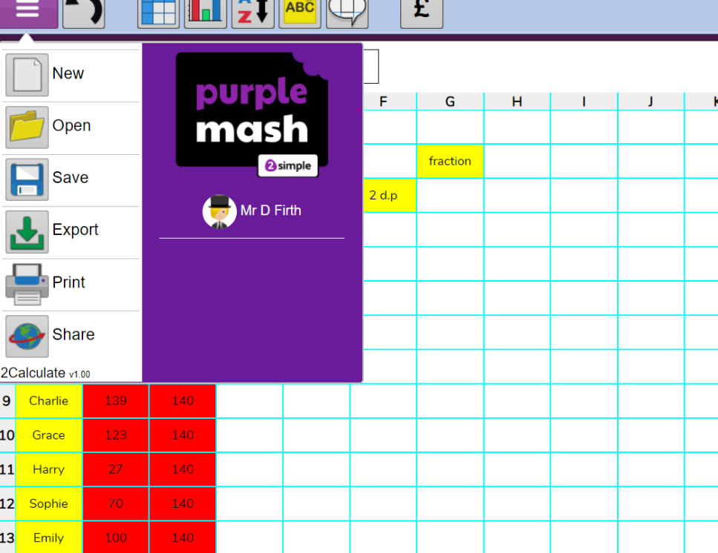  Then, answer the following questions about your spreadsheet in your books.  - Who has the highest percentage? What was it?  - Who has the lowest percentage? What was it?  - Who got 87.86%?  https://static.purplemash.com/mashcontent/applications/schemes_of_work/computing_schemes_of_work/computing_sow_year4_unit_4_3/Unit%204.3%20Spreadsheets.pdf
 | Art | Follow the link below for your drawing today:  Folding Surprise Frankenstein:  https://www.youtube.com/watch?v=0owwLsKNnvM  You will need a pencil and some paper.
 | PE | PE with Joe:  Keeping physically active is important, to support your child with their daily activity they can choose to do an online video lesson or choose to do some other type of activity to help them to keep fit and healthy. We have provided a couple of suggestions below:  https://www.youtube.com/watch?v=0VHkFJ8nqPw  https://peplanning.org.uk/downloads/pe-at-home/  This can be accessed, and the children can pick activities they would like to do. There are indoor and outdoor depending on the weather and space available.
 | Poetry | Click on the link and listen to the poem.  https://childrens.poetryarchive.org/poem/on-the-ning-nang-nong/  Recite the first six lines of the poem without looking.

