Timetable for Reception remote learning Spring 2 Reception Weeks 1 and 2 Monday 22nd Feb - Friday 5th Mar

Please find below the timetable for your child to complete during school time whilst their bubble is closed. The children can work through the lessons set each day, and just follow the link which will take you straight to the teaching/learning for that lesson. Children can record their work on the worksheets which have been sent home where appropriate or in their exercise books.
Mon 22nd Feb | Subject | Activity
 | Literacy | This week we are learning about Hansel and Gretel. Do you know this story? We are going to read the story and put actions to it. You will need to put actions to the words in red. Some of the actions are on the Pie Corbett sheet (the man showing the actions) and these actions need to be the same throughout the story - but, so, once upon a time. You can make your own actions for the other words. Have a great time.  Discuss the story and what happens. Who are the characters? What did they all want to do?  Can you remember what happened?  Retell the story in your own words.  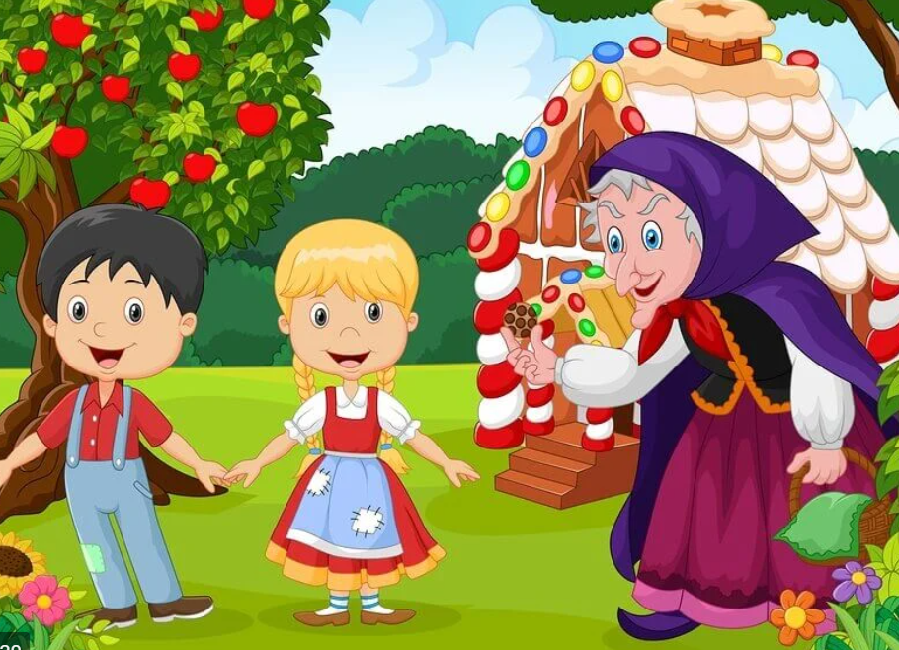
 | Reading | The pack contains storytelling dice. You will need to cut these out and create a 3D cube to roll. Children are to roll the dice and whatever picture it lands on needs to be in their story. Encourage the children to use their imagination to become an author and create their own story. They might think about stories they already know.  Click on the link and listen to the poem.  https://childrens.poetryarchive.org/poem/worm-words/  Listen to the poem with an adult
 | Phonics | Practise all sounds using the letter cards provided. Hold them up for children to see and say each sound, once they have said all sounds go through them together in case they said any incorrectly.  Today we are learning to blend sound that we already know. You will need some paper and a pencil before our video begins.  Online video https://www.youtube.com/watch?v=Jf2dx5IbeZE&list=PLuGr6z2H2KNF16mdL61bhR_pfztN5Vmjx&index=10  Sound Buttons – use your sheet marked Monday 22nd Feb and put sound buttons under the sounds. Remember to put a line under the digraphs. Did you spot the Tricky Word?
 | Maths | Combining 2 groups  For this activity you will need the witch picture. On here, you will see there are lots of groups of things i.e. 2 groups of cats.  Talk about the picture together and all the different things you see. Do you know what they all are? Can you name the objects?  You are going to ask the child to find the total of 2 groups by first counting how many in each group then by counting them altogether.  Here is an example:  How many teeth does the purple witch have?  How many teeth does the green witch have?  How many teeth do they have altogether?  Repeat with other groups. Use the examples on the corresponding sheet ot support with grouping objects – it gives fantastic ideas of the different groups you could use from the witch picture.  WRM online video  https://whiterosemaths.com/homelearning/early-years/growing-6-7-8-week-2/  Select session 3
 | Theme | Creating your very own house made of wonderful treats.  You could use a brown paper bag or a box for this activity. First, you will need to make some treats such as sweets, gingerbread, cakes etc. you could draw or paint these, cut them out and stick them onto your bag/box house.  What treat will your door be made of?  Which treat would work best to decorate the roof on your house?  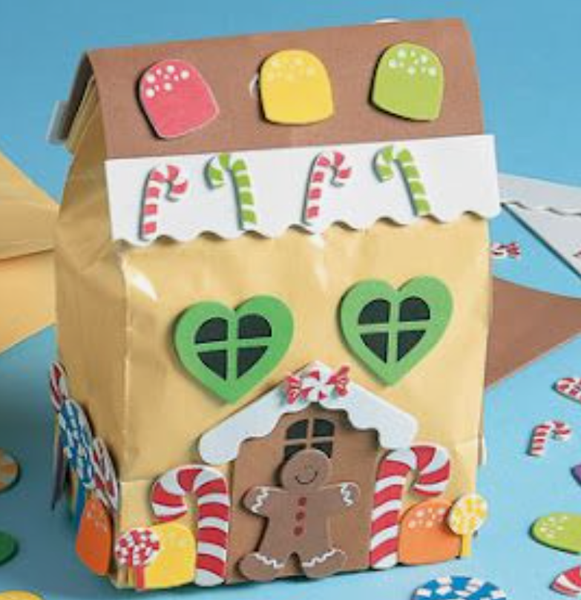
 | PE | Gross motor roll and exercise  Cut out the dice net dated Mon 22nd Feb. You will need to stick it together to create a dice shape so it can be rolled.  Simply roll the dice and complete the activity that it lands on.

Tues  23rd Feb | Subject | Activity
 | Literacy | Review the story of Hansel and Gretel, today you are going to draw a story map of the story. You will need to draw the important parts of the story to help you remember it. For example, the wood cutter and his wife, Hansel and Gretel, wife sending them away, the woods, breadcrumbs, sweetie house, witch, oven, going home. Use sheet 1 dated 23/2/21.  Watch a version https://www.youtube.com/watch?v=QVufSbEhN4c This story is a little bit different, can you spot the differences and similarities?
 | Reading | Oxford owl online reading books  https://www.oxfordowl.co.uk/  Once you click on the link, it is free to sign up and access the ebooks. Once you have logged on, select the home page and click on ‘Oxford Owl ebook library’. Choose one of the many books from the list to explore. Don’t forget to say the sounds and blend them together to read the word. Can you spot any digraphs (sound with 2 letters such as ‘oi’) or trigraphs (sound with 3 letters such as ‘igh’)?  Talk about the story as you read. What can you see? What do you think could happen next in the story? Can you imagine what might happen at the end?  Click on the link and listen to the poem.  https://childrens.poetryarchive.org/poem/worm-words/  Draw a worm.
 | Phonics | Practise all sounds using the letter cards provided. Hold them up for children to see and say each sound, once they have said all sounds go through them together in case they said any incorrectly.  Today we are learning to blend sound that we already know. You will need some paper and a pencil before our video begins.  Online video https://www.youtube.com/watch?v=X2C_ANTT7zs&list=PLuGr6z2H2KNF16mdL61bhR_pfztN5Vmjx&index=9  Phoneme Spotter – use the sheet marked Tuesday 23rd Feb. Can you spot all the ‘or’ graphemes? Put a ring around them when you find them. Have a go at reading the sentences with your grown-up.
 | Maths | Combining 2 groups  Dominoes  Cut out the dominoes and lay them face down on the floor or table. Each person to pick up one domino at the same time. Can you recognise how many dots are on each side without counting? Count if you need to. Then count how many altogether. The one with the most dots altogether wins both dominoes.  WRM online video  https://whiterosemaths.com/homelearning/early-years/growing-6-7-8-week-2/  Select session 4
 | Theme | People and communities  Who are our friends? What makes them similar or different to us and our families?  Think about who is in your family such as extended family, siblings, who you live with and compare to your friend’s families.  Does it matter that we might be different? How are we different?  Talk about how being different can be a good thing and why? Do we all need to be the same? What could we learn?  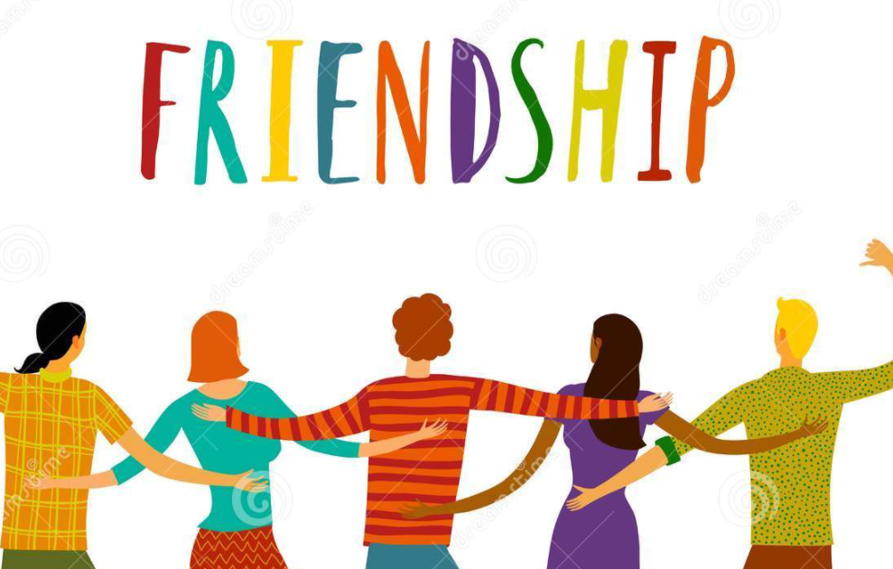
 | PE | PE with Joe:  Keeping physically active is important, to support your child with their daily activity they can choose to do an online video lesson or choose to do some other type of activity to help them to keep fit and healthy. We have provided a couple of suggestions below: https://www.youtube.com/watch?v=hnOtrnh80hs  https://peplanning.org.uk/downloads/pe-at-home/  This can be accessed, and the children can pick activities they would like to do. There are indoor and outdoor depending on the weather and space available.

Wed 24th Feb | Subject | Activity
 | Literacy | Refresh yourself with the story of Hansel and Gretel. Today you are going to write simple captions on your story map to match the pictures you have drawn. Continue to use sheet 1 dated 23/2/21. Remember to use your phonic skills to help you write the words.  Refresh your story using your actions.
 | Reading | Become a storyteller.  Children are to become a storytelling character – they could dress up as a storytelling using their imagination (this could be random clothing, capes, hats, costumes)  Encourage your child to read one of their favourite stories to you. They can use the pictures and their memory of the story to help them retell it correctly.  How were your storytelling skills?  Did you enjoy being a storyteller?  Click on the link and listen to the poem.  https://childrens.poetryarchive.org/poem/worm-words/  The word worm begins with a ‘W’. Try and practise writing a line of ‘W’s.
 | Phonics | Practise all sounds using the letter cards provided. Hold them up for children to see and say each sound, once they have said all sounds go through them together in case they said any incorrectly.  Today we are learning to blend sound that we already know. You will need some paper and a pencil before our video begins.  Online video https://www.youtube.com/watch?v=pcNgbnrvWqo&list=PLuGr6z2H2KNF16mdL61bhR_pfztN5Vmjx&index=8  Use the sheets marked Wednesday 24th Feb to read some ‘ur’ words. Fold the page over to hide the picture before you begin. Read the word and then look at the picture to check. You might want to cut them out first.
 | Maths | Combining 2 groups  Part whole model  Please see worksheet date Wed 24th Feb  This model is fantastic for helping to see how 2 groups come together to make 1.  You will need some small objects to 10 (add more if they need the challenge of higher number)  First, we place objects into the bottom 2 circles to create 2 groups – you decide how many.  Can they tell you how many objects are in each group?  To work out how many altogether, they can push each object up the line into the top circle. When all objects are in there, they can count how many altogether.  Try with different amounts of objects to make a different total.  Can they recognise how many objects are in each group without counting?  WRM online video  https://whiterosemaths.com/homelearning/early-years/growing-6-7-8-week-2/  Select session 5
 | Theme | People and communities  I would like you to think of special times in your life such as a wonderful place you have visited or celebrating a special occasion. Why do you think it was special? What made it special to you? Tell your grown up all the things you remember about it.  Do you have any photos you could look through that would help remind you of the special occasion?
 | PE | Target throw  Have a basket or big tub as a target – the challenge is for you to aim and throw a ball (outdoors) or soft toy (indoors) so it lands in the target. Out of 10 throws, how many did you get in?  You could try this using both underarm and overarm throws.  You could try throwing it up high?  You could try throwing it with the hand you don’t usually throw with i.e. if you are right handed, try with your left.  .  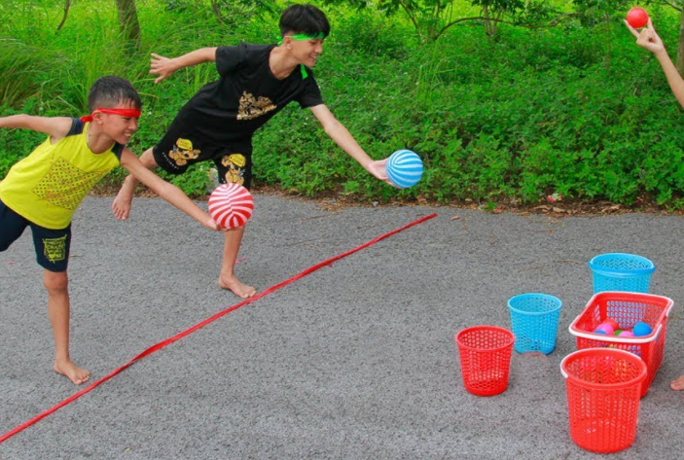

Thurs 25th Feb | Subject | Activity
 | Literacy | Today your task is to read the words in the jumbled sentences and cut them up to make a correct sentence. Do one sentence at a time. Cut out the sentence line and then the words. When you have the correct order stick them into your book. Use sheet 2 dated 25/2/21  Refresh your story using your actions.
 | Reading | Changing our favourite stories.  Think of a favourite story you have or a traditional tale you have learnt at school such as The gingerbread man. Can you remember the story? As you read it or retell the tale, try and change some parts to make it a funny tale. Maybe in your story the gingerbread man became a banana girl or a cupcake boy. Maybe your story doesn’t have a sly fox but a cheeky monkey or a sneaky swan.  Click on the link and listen to the poem.  https://childrens.poetryarchive.org/poem/worm-words/  Try saying the poem out loud with an adult.
 | Phonics | Practise all sounds using the letter cards provided. Hold them up for children to see and say each sound, once they have said all sounds go through them together in case they said any incorrectly.  Today we are learning to blend sound that we already know. You will need some paper and a pencil before our video begins.  Online video https://www.youtube.com/watch?v=DV3vzwk9E_Q&list=PLuGr6z2H2KNF16mdL61bhR_pfztN5Vmjx&index=7  Reading real and nonsense words – use your sheet marked Thursday 25th Feb. Choose a colour to colour in all the real ‘ow’ words. Choose a different colour to colour in all the nonsense ‘ow’ words.
 | Maths | Combining 2 groups  Part whole model  This model is fantastic for helping to see how 2 groups come together to make 1.  This activity is the same as yesterday but instead of using objects we are using dice and dots.  Use the two dice in the previous pack. First, we need to add dots to the 2 bottom circles. First die - roll it and draw that amount of dots into the circle, second die- roll it and draw that amount of dots into the second circle.  Ask the children how many dots in each group?  Explain that we cannot move the dots to the top circle as we have drawn them on, so how can we find out the total altogether.  Ensure the children count all the dots and when they find the number of dots altogether they can write that number into the top circle.
 | Theme | Trial through the woods  For this activity you will need paper and coloured pencils.  You need to draw a picture of the woods/forest – use what you have seen during your own walks through the woods to help you add detail. If you are unsure of what it might look like, the adults can help you by showing you images. Don’t forget to draw the woodcutters house.  Once your picture is complete you need to add a trail from one side to the other – draw small breadcrumbs or pebbles leading from the house into the woods. Would you be able to find your way back if you have to follow them?  Which way does you trail go? Do you have to travel across the river?  Explain to your adult how your trail will lead you back to the cottage. Could anything go wrong?  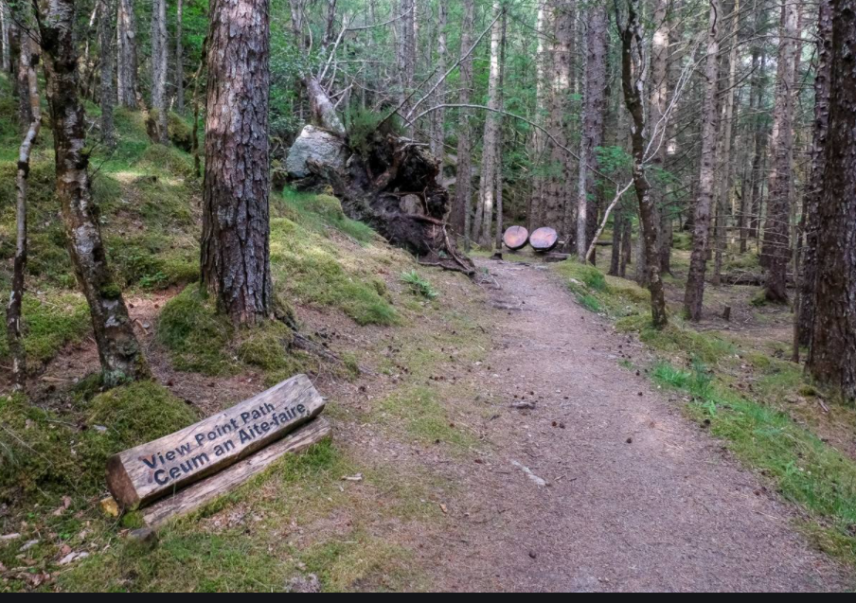
 | PE | PE with Joe:  Keeping physically active is important, to support your child with their daily activity they can choose to do an online video lesson or choose to do some other type of activity to help them to keep fit and healthy. We have provided a couple of suggestions below:  https://www.youtube.com/watch?v=xs_g2B-D7zg  https://peplanning.org.uk/downloads/pe-at-home/  This can be accessed, and the children can pick activities they would like to do. There are indoor and outdoor depending on the weather and space available.

Fri  26th Feb | Subject | Activity
 | Literacy | Today you are going to retell the story you have been learning. Use your story map to help you remember the correct sequence of the story. Don’t forget to use the actions you have been learning, they can help you remember the story too. Ask someone to video you and then up load it to ‘Evidence Me’
 | Reading | Booktrust – online reading books  Click on the link and share the story ‘A hole in the bottom of the sea’. This is an audio book that you can read along to.  Have fun exploring this wonderful book of creatures from the bottom of the sea.  https://www.booktrust.org.uk/books-and-reading/have-some-fun/storybooks-and-games/  Click on the link and listen to the poem.  https://childrens.poetryarchive.org/poem/worm-words/  Pretend to be a wiggly worm using your finger.
 | Phonics | Practise all sounds using the letter cards provided. Hold them up for children to see and say each sound, once they have said all sounds go through them together in case they said any incorrectly.  Today we going to review all the learning from this week. You will need some paper and a pencil before the video begins.  Online video https://www.youtube.com/watch?v=-GungrFDNmk&list=PLuGr6z2H2KNF16mdL61bhR_pfztN5Vmjx&index=6  Reading Comprehension – use your sheet marked Friday 26th Feb. Read the sentences and then draw the part that is missing.
 | Maths | Combining 2 groups  For this activity you will need a coat hanger and 10 pegs.  Place a number of pegs (between 1 and 10) onto the coat hanger.  The children are to separate into 2 groups so there are some pegs at one side and some pegs on the other side.  How many pegs are there on each side? How many pegs are there altogether? How can we find out?  We can push the pegs back together to make one big group and count them.  Explore this activity with using a different amount of pegs.
 | Theme | Trail walk  Your challenge today is to be Hanzel and Gretel whilst you are out on your walk. For this you will need bread to use as crumbs and don’t forget to wrap up warm in this very cold weather. As you walk, drop breadcrumbs (small pieces of bread) so it leaves a trail behind you. Once you have come to the end of your walk, travel back the same way following the breadcrumbs as you go.  Are the crumbs still there?  If not, where could they have gone?  Would you be able to find your way back with crumbs to follow?  You can complete this task on a walk around where you live or in woods if you are visiting there today.
 | PE | Keep the Balloon Up  This activity could be done outdoors on a calm, windless day, or inside. The challenge is to keep the balloon off the ground for as long as possible. They can use their hands, feet or a bat of some sort. How long can they keep the balloon off the ground?

Mon 1st Mar | Subject | Activity
 | Literacy | Today you will be exploring your story map in detail and you need to think about the characters and where the story is set. Your task today will be to change 2 parts of the story, for example, you could change the witch for another character, or the cage into a cave. You may choose to use characters you know from other familiar stories. Draw the two new changes on the post it notes from your pack, then stick over your changing parts.  Now retell your story with your changes.
 | Reading | Use the storytelling dice again. Children are to roll the dice and whatever picture it lands on needs to be in their story. Encourage the children to use their imagination to become an author and create their own story. They might think about stories they already know. How if their story different to the last one? Did they have different characters or a different setting.  Click on the link and listen to the poem.  https://childrens.poetryarchive.org/poem/splish-splash-splosh/  Repeat the line ’Splish, splash,splosh’
 | Phonics | Practise all sounds using the letter cards provided. Hold them up for children to see and say each sound, once they have said all sounds go through them together in case they said any incorrectly.  Today we are going to play Letters and Sounds Bingo! Do you remember playing it in school?  https://www.ictgames.com/mobilePage/bingoOriginal/index.html  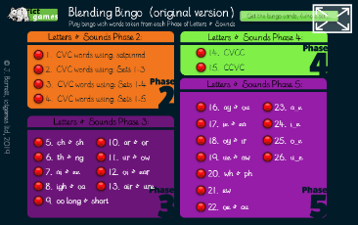  Click on number 5 – ‘ch’ & ‘sh’ to reveal the bingo game. Click on the red handle to generate the word. Use the sheet marked Monday 1st March. Cut the Bingo cards out and play with your grown-up. You can have 2 games, using a card each!
 | Maths | Comparing height  Gather a variety of soft toys or figures that you enjoy playing with. They can be of all different sizes and heights.  Can you estimate which toy will be the tallest or shortest?  To find out if your estimation is correct, place your toys in a line in order of height, starting with the shortest – the line will go from shortest to tallest. Was your estimation correct?  Name a toy that is shorter than …… (there may be more than 1 toy that is shorter than….)  Name a toy that is taller than…(there may be more than 1 toy that is taller than….)  Now, using the people in your house, can you find out who is the tallest, shortest and who is in the middle.  WRM online video  https://whiterosemaths.com/homelearning/early-years/growing-6-7-8-week-3/  Select session 1
 | Theme | Helping our grown ups  Today, I would like you to help with the cooking/baking. How can you help? It is very important that you listen to your adult and follow instructions so you can stay safe in the kitchen.  What did you help to make?  Did you have an important job to do?  Did other people enjoy your meal/baking?  Don’t forget to help with the tidying up too.
 | PE | Gross motor roll and exercise  Cut out the dice net dated Mon 22nd Feb. You will need to stick it together to create a dice shape so it can be rolled.  Simply roll the dice and complete the activity that it lands on.

Tues  2nd Mar | Subject | Activity
 | Literacy | Today you need to write a simple sentence about one of the characters you changed in the story. Use sheet 3 dated 2/3/21  Remember to use your phonic knowledge to hear, say and write the sounds in the words.  Re-tell your new story.
 | Reading | Oxford owl online reading books  https://www.oxfordowl.co.uk/  Once you click on the link, it is free to sign up and access the ebooks. Once you have logged on, select the home page and click on ‘Oxford Owl ebook library’. Choose one of the many books from the list to explore. Don’t forget to say the sounds and blend them together to read the word. Can you spot any digraphs (sound with 2 letters such as ‘oi’) or trigraphs (sound with 3 letters such as ‘igh’)?  Talk about the story as you read. What can you see? What do you think could happen next in the story? Can you imagine what might happen at the end?  Click on the link and listen to the poem.  https://childrens.poetryarchive.org/poem/splish-splash-splosh/  Pretend to splash in your own puddle.
 | Phonics | Practise all sounds using the letter cards provided. Hold them up for children to see and say each sound, once they have said all sounds go through them together in case they said any incorrectly.  Today we are thinking about digraphs – two letters that make one sound.  Online game – Phonics Play: https://www.phonicsplay.co.uk/ username: jan21 password: home  Click on ‘resources’, then phase 3, then ‘pick a picture’, then phase 3 digraphs.  Now practice writing these words from the game: fish, ring, jeep, moon, cart, road, cow, shell, boat.
 | Maths | Comparing length  For this activity you will need the coloured strips from the pack (cut out), a piece of paper and a glue stick.  Your first job is to put the strips in order of length – if you lay them all down next to each other you can pick out the shortest and glue that one first. Then you can see which is the second shortest and work up to the longest strip.  Remember, only glue them in place if you are absolutely sure they are in order.  For this activity you will need paper, a pencil and to borrow the feet of the people in your house.  Draw round their feet to create a footprint – we are going to find out who has the longest feet.  Put them in order of longest to shortest and label the footprints with the names of who they belong to.  WRM online video  https://whiterosemaths.com/homelearning/early-years/growing-6-7-8-week-3/  Select session 2
 | Theme | Emotions for kids  https://www.youtube.com/watch?v=jetoWelJJJk  Watch the video about emotions – it will help you to understand some of the emotions we experience. Talk with each other about things that make you feel sad or happy, scared or excited.
 | PE | PE with Joe:  Keeping physically active is important, to support your child with their daily activity they can choose to do an online video lesson or choose to do some other type of activity to help them to keep fit and healthy. We have provided a couple of suggestions below:  https://www.youtube.com/watch?v=WDvjqO2VXa8  https://peplanning.org.uk/downloads/pe-at-home/  This can be accessed, and the children can pick activities they would like to do. There are indoor and outdoor depending on the weather and space available.

Wed  3rd Mar | Subject | Activity
 | Literacy | Today have a look at sheet 4 dated 3/3/21. This is a writing frame and it can help you remember important parts of the story. Recap the story such as the settings and scenes. What happens in the beginning, in the middle and at the end of the story? Write a simple caption for each.
 | Reading | Become a storyteller.  Children are to become a storytelling character – they could dress up as a storytelling using their imagination (this could be random clothing, capes, hats, costumes)  Encourage your child to read one of their favourite stories to you. They can use the pictures and their memory of the story to help them retell it correctly.  How were your storytelling skills?  Did you enjoy being a storyteller?  Click on the link and listen to the poem.  https://childrens.poetryarchive.org/poem/splish-splash-splosh/  Try and draw a penguin.
 | Phonics | Practise all sounds using the letter cards provided. Hold them up for children to see and say each sound, once they have said all sounds go through them together in case they said any incorrectly.  Today we are going to play Letters and Sounds Bingo!  https://www.ictgames.com/mobilePage/bingoOriginal/index.html  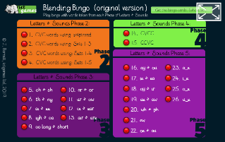  Click on number 6 – ‘th’ & ‘ng’ to reveal the bingo game. Click on the red handle to generate the word. Use the sheet marked Wednesday 3rd March. Cut the Bingo cards out and play with your grown-up. You can have 2 games, using a card each!  Now write a sentence with the word ‘king’ in it. Write another sentence with the word ‘bath’ in it.
 | Maths | Warm up – singing our days of the week and months of the year song.  Days of the week  In the pack you will see a booklet showing all the days of the week. Can you name the days of the week in the correct order?  For each day, can you draw a picture of something you do that day? If you are starting today, which day will you need to draw for?  If today is Wednesday, what day is tomorrow?  What day was yesterday?  What days are the weekdays? How many are there?  Can you tell me what days we call the weekend? How many are there?  WRM online video  https://whiterosemaths.com/homelearning/early-years/growing-6-7-8-week-3/  Select session 3
 | Theme | Feelings  For this activity you will need paper and coloured pencils.  Your task is to think about all of the characters in the Hanzel and Gretal story and how they might feel.  Are they happy, sad, angry, confused, surprised? In some parts of the story they might feel very differently to others so you need to decide when you would like to draw each characters feelings.  For example – if you draw Hanzels face when they are in the woods it might be a worried/sad face but if you draw her face when they arrive back home it might be a happy face.
 | PE | Balancing beam  The challenge is to walk across the beam using your balancing skills and not fall off. Indoors, you could use tape to make a straight line on the floor. Encourage your child to walk forwards, backwards, and sideways. Outdoors, use a plank of wood, a rope, or make a line with chalk for the same activity. When your child masters a straight line, add semi-circles or zigzags to add a bit more of a challenge.

Thursday 4th March 2021
World Book Day
Please see separate World Book Day folder for timetable and resources

Fri  5th Feb | Subject | Activity
 | Literacy | Today your task is to find the word hidden in the word search Sheet 5 dated 5/3/21 Good luck.  Now look at sheet 6 (5/3/21) can you draw a line from the character’s name to the right character picture.  We hope you have enjoyed learning the Hansel and Gretel story.  So far, the traditional tales you have learnt are ‘The gingerbread man’ and ‘Hanzel and Gretal’.  Which story was your favourite?  Can you explain why?  Who was your favourite character? What did you like about them?
 | Reading | Booktrust – online reading books  Click on the link and share the story ‘Open very carefully’. This is an audio book that you can read along to.  Have fun exploring this wonderful book but be careful, something might bite!  https://www.booktrust.org.uk/books-and-reading/have-some-fun/storybooks-and-games/  Click on the link and listen to the poem.  https://childrens.poetryarchive.org/poem/splish-splash-splosh/  Talk to an adult about when you last splashed in a puddle.
 | Phonics | Practise all sounds using the letter cards provided. Hold them up for children to see and say each sound, once they have said all sounds go through them together in case they said any incorrectly.  Today we going to review all the learning from this week. First, practice some Tricky words.  username: jan21 password: home  https://www.phonicsplay.co.uk/resources/phase/3/tricky-word-trucks  Then practice reading some sentences.  https://www.phonicsplay.co.uk/resources/phase/3/sentences-3  Finally, let’s play a board game! Use your Read and Race Game sheet (instructions included)
 | Maths | Measuring time  For this activity you will need a stopwatch – or you can use a timer on a phone or computer/tablet. (needs to be visible to the child).  How quickly can you ………? Think of some actions you could do and time how quickly you can do them.  Here are some examples:  10 jumps  Running upstairs and back down  Finding 5 different objects and bringing them back  Tidy up toys  Write your name  Run to the end of the garden and back  WRM online video  https://whiterosemaths.com/homelearning/early-years/growing-6-7-8-week-3/  Select session 5
 | Theme/PE | Dance party  Indoors or outdoors, turn up the music, use lights or decorations to create a dancing hall, and let your kids twist, macarena, floss, dance like their favourite animal, or freestyle their way to fun.  This will help them to build up a repertoire of dances and experiment with different ways of moving.

