Thurs 4th March | Subject | Activity
 | Literacy | We’re going on a Bear Hunt.  Read or watch the story of Bear hunt together-  https://www.youtube.com/watch?v=Iou5LV9dRP0&ab_channel=Kids%E2%80%99PoemsandStoriesWithMichaelRosen  Can you create your own junk model bear? How many eyes does it need? How many ears?
 | Phonics | In the story of the Bear Hunt there are lots of different noises, listen again to the noises from the story. Go on your own bear hunt around your local area, what sounds can you hear?
 | Maths | Ordinal Numbers  What order did the children make their journey in? Where did they pass first, where did they pass second? How many paces did they go? Can you make a Story Map to show where they went and the order that they went in?  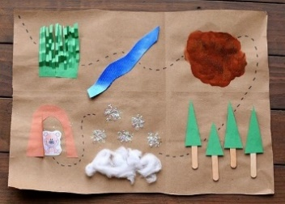 (Example story map)
 | Theme | What can you find out about bears? Where do they live? What do they eat? What do they like to do?  Bears live in big caves and dens, can you build your own den? It could be an indoor den using blankets and cushions or an outdoor den using old sheets! Make a sign to put outside your den so that everyone knows who it belongs to!  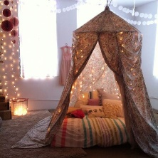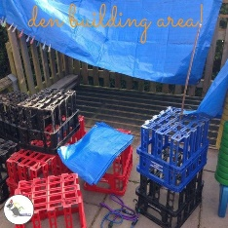
 | PE | Go on your own Bear Hunt around your local area (link to phonics activity). What different ways can you move around on your walk, can you jump over a crack in the pavement or hop around a puddle for example, can you run away from the bear?
Our special World Book Day Live Lesson will be at 11am. Don’t forget to dress up as your favourite character!

