Learning Plan Year 11
Week Commencing : 26th April

Subject | Activity | Links | QA
English | All Year 11 English work will be emailed directly to students by their English teacher.  If there are any issues, or if no work is received, please email your English teacher or Miss Clark (Assistant Leader for English). | Y11 teacher email addresses:  matthew.law@appletonacademy.co.uk  megan.clark@appletonacademy.co.uk  kathryn.boyle@appletonacademy.co.uk  elliot.caw@appletonacadeny.co.uk  rebecca.whittaker@appletonacademy.co.uk  clare.williams@appletonacademy.co.uk

Subject | Activity | Links | QA
Maths | Lesson 1  Login to Hegarty maths. If you do not know your password, click "forgotten your password” and email your teacher to let them know. They will reset this for you.  Complete the revision quiz numbers below for your class. Email your class teacher if you need any support.  Foundation  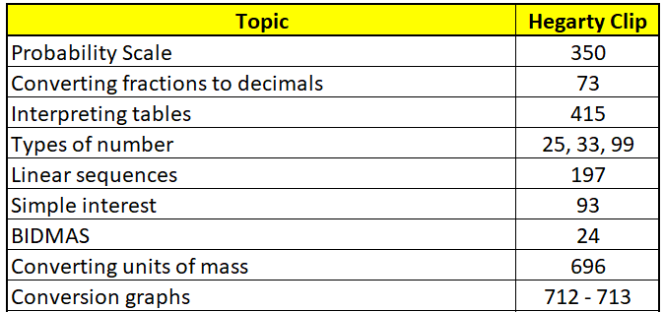  Higher  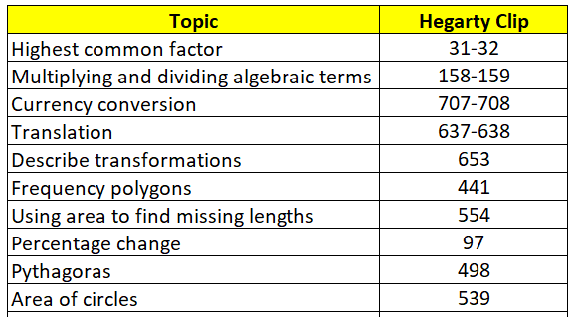 | https://hegartymaths.com/
 | Lesson 2  Login to Hegarty maths. If you do not know your password, click "forgotten your password” and email your teacher to let them know. They will reset this for you.  Complete the revision quiz numbers below for your class. Email your class teacher if you need any support.  Foundation  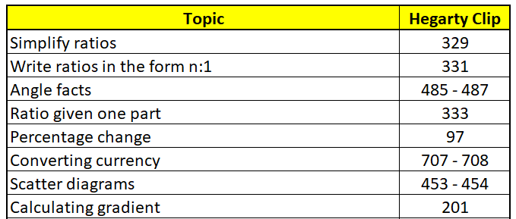  Higher  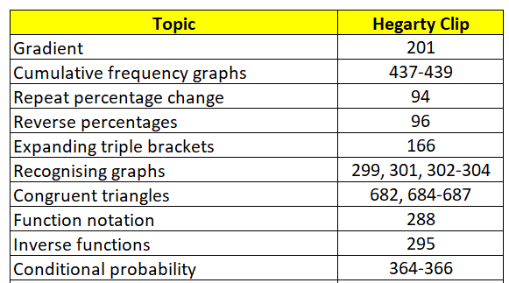 | https://hegartymaths.com/
 | Lesson 3  Login to Hegarty maths. If you do not know your password, click "forgotten your password” and email your teacher to let them know. They will reset this for you.  Complete the revision quiz numbers below for your class. Email your class teacher if you need any support.  Foundation  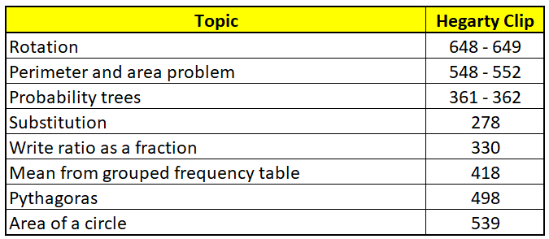  Higher  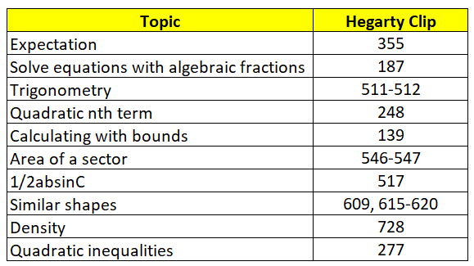 | https://hegartymaths.com/

Subject | Activity | Links | QA
Science | Lesson 1  Combined Science: Inheritance and variation  Triple Science: Chemical changes: reactivity series, acids and electrolysis | Combined Science: Inheritance and Variation  - Watch any of the Oak National Academy videos here: https://classroom.thenational.academy/units/inheritance-variation-and-evolution-0224  - Make notes of the key information while you are watching and complete any written tasks included in the video  - Complete the Remote Learning Educake linked to this lesson  - Upload your work to Teams or email to your teacher.  Triple Science: Chemical Changes  - Watch any of the Oak National Academy videos here: https://classroom.thenational.academy/units/chemical-changes-a5ba  - Make notes of the key information while you are watching and complete any written tasks included in the video  - Complete the Remote Learning Educake linked to this lesson  - Upload your work to Teams or email to your teacher.
 | Lesson 2  Combined Science: Ecology and sampling  Triple Science: Energy changes including bond energies and profiles | Combined Science: Ecology and Sampling  - Watch any of the Oak National Academy videos here: https://classroom.thenational.academy/units/ecology-a6da  - Make notes of the key information while you are watching and complete any written tasks included in the video  - Complete the Remote Learning Educake linked to this lesson  - Upload your work to Teams or email to your teacher.  Triple Science: Energy Changes  - Watch the Oak National Academy video here: https://classroom.thenational.academy/units/energy-changes-b607  - Make notes of the key information while you are watching and complete any written tasks included in the video  - Complete the Remote Learning Educake linked to this lesson  - Upload your work to Teams or email to your teacher.
 | Lesson 3  Combined Science: Rates of reaction and organic chemistry: hydrocarbon  Triple Science: Energy | Combined Science: Ecology and Sampling  - Watch any of the Oak National Academy videos here: https://classroom.thenational.academy/units/the-rate-and-extent-of-chemical-change-0530 and https://classroom.thenational.academy/units/organic-chemistry-7c58  - Make notes of the key information while you are watching and complete any written tasks included in the video  - Complete the Remote Learning Educake linked to this lesson  - Upload your work to Teams or email to your teacher.  Triple Science: Energy  - Watch any of the Oak National Academy videos here: https://classroom.thenational.academy/units/energy-c750  - Make notes of the key information while you are watching and complete any written tasks included in the video  - Complete the Remote Learning Educake linked to this lesson  - Upload your work to Teams or email to your teacher.

Subject | Activity | Links | QA
Geography | PAPER 1 MOCK  This will be emailed directly by your geography teacher. You must compete this under exam conditions and allow yourself 90 mins to complete the paper. Email your completed paper to your geography teacher or bring it back into school on your return
 | Challenges of urban areas revision. Mumbai  Use the knowledge check and the urban information to revise this topic before completing the check 20. Give yourself 20 mins in exam conditions to complete the check 20. The check 20 needs to be submitted to your geography teacher | Mumbai documents
History | Lesson 1  How far was Elizabethan England a Golden Age?  In this lesson, we will evaluate changes in literature, theatre and art before making a judgement about how far Elizabeth’s reign was a golden age.  Complete the work on the PowerPoint and email it to your teacher. | Lesson Resources
 | Lesson 2  The Great Rebuilding and Kenilworth Castle  In this lesson, we will revise the Great Rebuilding and Kenilworth Castle.  Complete the work on the PowerPoint and email it to your teacher. | Lesson Resources
Spanish | 1 – Mock Reading Paper  Your teacher will email you a copy of the reading paper directly if required.  You must complete this paper in exam conditions and email it to your teacher or bring it with you when you return to school. | Miss Shepherd: april.shepherd@appletonacademy.co.uk  Miss Sanchis: anna.sanchis@appletonacademy.co.uk
 | 2 – Effective communcation  In this lesson we’ll be considering strategies which we can use to aid effective communication in, particularly, spoken Spanish. Your teacher will email you work which can be completed remotely if required.  You should email your work back to your teacher or upload it to the ‘Completed Work’ folder for this week on Teams. | Miss Shepherd: april.shepherd@appletonacademy.co.uk  Miss Sanchis: anna.sanchis@appletonacademy.co.uk  Click here to upload your work to Teams
Business | Lesson:  Looking at risk assessments; This part of the assignment and coursework requires you to complete a risk assessment for your business.  Entrepreneurs are often described as risk takers. This is because, unfortunately, many small businesses do not manage to succeed.  A risk assessment is the process of:  - Identifying potential risks to a business  - Considering the likelihood of these risks turning into problems  - Judging whether or not the benefits of something outweigh the potential risks associated with it.  Activity and task:  You need to produce a risk assessment and contingency plan to ensure the quality of the product or service that includes:  - The risks of setting up your own business  - How you plan to overcome these risks and issues should they arise.  Answer the questions and fill in the table to assist you in completing the risk assessment for your chosen business.  I have included the questions that need to be answered, the sheet that needs to be completed and also an example from the exam board for you to help and assist you. | Example - Risk assessment  Risk assessment questions  Risk assessment Template
Photography | AVE: Fragment photography personal project  Task: Composition development  Using a Venn diagram, compare the work of your two artist/ photographers.  Task: Using a storyboard, plan design ideas inspired by your two Fragment photographers for your final piece(s), experimenting with different compositions and media.  Techniques/ media to consider:  -Wax resist  -Batik  -Image transfer  -Embroidery  -Glass  -Weaving  -Collage  -Mix media  -Painting  -Photoshop/ digital art  If working from home, email all work to heather.aveyard@appletonacademy.co.uk to receive feedback.  All powerpoints are saved on Teams with exemplars.
Art | During your personal project, so far, you have explored a wide range of artists and drawing from primary & secondary sources.  Your next step is to develop 4 designs of your own in preparation for a final piece. We call this ‘composition development’.  Task – For this weeks lessons you will create 1 rough design idea for a final piece. To do this you must merge your primary and/or secondary drawings together. Add loose colour based upon your chose artist.  Hand in – Email images of completed work to:  Anna.wallace@appletonacademy.co.uk
Product Design | n product design work for isolating students will be emailed directly. Please check your 365 school email.  In Product Design work will be emailed directly to isolating students.  Please check your school email regularly during the course of the week.  Task: For this weeks lessons you need to go through the checklist for each page of your coursework, this checklist is saved in your Teams file.  Checklist:  -Make sure each page has a bold title at the top of the page  -Make sure any mistakes are erased  -Make sure you have summarised each page by explaining what you have done and how it will support your design process in a few sentences.  -Make sure designs are completed and annotated where necessary  -Read and check your work to make sure there are no mistakes  You need to make sure that you have finished every page of your coursework, even if this means going back to work done at home.  You will need to produce a model of your design in order for you to be properly assessed. | Send your work to  christina.tsobanoglou@appletonacademy.co.uk  Rachel.henshaw@appletonacademy.co.uk
Food | Lesson 1  Starter – What do the symbols mean?  Task 1: Watch this video of how this hotel has made has been made to be sustainable make notes on this as you will need them for task 2.  Once you have made notes watching that video https://www.youtube.com/watch?v=SQ7h00UTe2M  , look at the next two links of a blog that explain what hotels have to do to become more sustainable, if you have missed any of these points from the video then please add to your notes now using the information from the blog. https://ecobnb.com/blog/2019/06/ecological-quality-green-hotel/  https://ecobnb.com/blog/2018/12/green-hotel-actions/  Task 2: Complete the mind map on your resource on hotels showing how they can become more sustainable. Or  Create a poster for one area of a hotel encouraging staff and customers to adopt more sustainable practices.  Plenary: There are various standards you can find on food packets that make sure our food is sourced and produced sustainably.  At home can you look at the food packaging you have and see if you can identify any.  Take a photograph or record your research. | https://www.youtube.com/watch?v=SQ7h00UTe2M  https://ecobnb.com/blog/2019/06/ecological-quality-green-hotel/  https://ecobnb.com/blog/2018/12/green-hotel-actions/  Lesson
 | Lesson 2  Starter – Write a tweet explaining What do we already understand about the greenhouse effect, global warming and climate change?  Task 1: Read slides 3-5 and then answer the questions on slide 6 on your resource sheet. This is make a list on What will be the effects of the greenhouse effect, global warming and climate change on food production? and How will this impact on people?  Task 2: Next to the footprint in your resource mind map how you think food production contributes to global warming and climate change.  Task 3: Read the slides above about food waste and watch this video of how councils can reuse food waste Recycling food waste  Produce a persuasive speech to convince someone that they should waste less food and suggest how they could do it.  Plenary: What do you think seasonality is? | Recycling food waste  Lesson
Sport CRO and KER | Lesson 1 - All 14 tasks have been sent out via email that can be watched on loom. Please access the unit 2 work booklet through one drive and work through the tasks for unit 2 coursework.
 | Lesson 2 - All 14 tasks have been sent out via email that can be watched on loom. Please access the unit 2 work booklet through one drive and work through the tasks for unit 2 coursework.
Sport BWD | Lesson 1 - All 14 tasks have been sent out via email that can be watched on loom. Please access the unit 2 work booklet through one drive and work through the tasks for unit 2 coursework.
 | Lesson 2 - All 14 tasks have been sent out via email that can be watched on loom. Please access the unit 2 work booklet through one drive and work through the tasks for unit 2 coursework.
Sport Tech Ker | Lesson 1 - Complete all corrections to component 1 coursework that has been uploaded to your one drive. Personalised emails have also been sent out to help you complete these.
 | Lesson 2 - Complete all corrections to component 1 coursework that has been uploaded to your one drive. Personalised emails have also been sent out to help you complete these.
Child development | Lesson 1 - On laptops, begin to make corrections to unit 3 assignments  If this is complete, start unit 2 assignments | https://www.loom.com/share/208aa1d7afea453d88e97478f13062ee?sharedAppSource=personal_library  https://www.loom.com/share/3c14d7e74b2640658048b114b1ef901c?sharedAppSource=personal_library
 | Lesson 2 - On laptops, begin to make corrections to unit 3 assignments  If this is complete, start unit 2 assignments | https://www.loom.com/share/208aa1d7afea453d88e97478f13062ee?sharedAppSource=personal_library  https://www.loom.com/share/3c14d7e74b2640658048b114b1ef901c?sharedAppSource=personal_library
Health and Social Care | 11D – Component 2 Aim B – Complete slides 1-21, respect for others and dignity.  11B – Individualised feedback on coursework. | Powerpoint
 | 11D – Component 2 Aim B – Complete slides 22-32, effective communication and anti-discriminatory practice.  11B – Individualised feedback on coursework. | Powerpoint
Drama | Students are focusing on prep for Component 3 exams. In the Y11 Remote Learning, Performing Arts TEAMs Channell, there will be a folder with a document full of practise exam questions. Students must answer however many they can, in detail, to the best of their ability – in the 90 minute slot they would usually have for their in school lesson.  Exam question responses must then be sent to Miss Bottomley at stephanie.bottomley@appletonacademy.co.uk | Practise exam questions | BTM
Music | Year 11 are all at various points on their Unit 4 composition coursework. All home learning is catered for on an individual basis via their TEAMs channel. Mr Ayres will email out the personalised learning for students as required.  Students can contact Mr Ayres at mark.ayres@appletonacademy.co.uk | Year 11 Music TEAMs Channel | BTM
Media Production | Teams – AAC 11A/Mp1 - Component 3 – Files – Your Name – Task 1.pptx  Continue to meet the pre-production section of the assignment brief by writing  -purpose and audience to brief response  -moodboard and mindmap  -secondary research into existing competition  -primary research and results  -house style sheet  Or Task 2.pptx  -three+ separate draft ideas based on house style sheet  Email or Teams post Mr Halston when these sections are complete | Click here to access the Component 3 channel | HAL
iMedia | 11B/IM1  R086 – Creating a Digital Animation Improvements  In the R086 channel, then in the Files tab, and then in the Video Feedback folder, you will see a personalised video explaining what to do to improve your R086 assignment.  Work on LO1, LO2 and LO4 to get your mark up.  You can see the tracker in the General Files tab to see what mark you need to get to the next grade.  You will need to respond in the R086 Posts tab to confirm you have acted upon the feedback and made the improvements. | 11B/Im1 Link to Feedback Videos  Link to Tracker
 | 11D/Im1 - Teams – AAC 11D/Im1 - Class Notebook – Your Name – R086 lessons – Lesson 9 Animation Techniques  Or..  Start to paste the amber/green written sections plus any images and videos into the Assignment 1 template on Teams (in the r086 Files tab, in the folder with your name)  Complete the lesson and inform Mr Halston by email or Teams post to receive feedback.  Make sure all lessons up to 9 are complete for this week | 11D/Im1 - Click here to access the Class Notebook | HAL
Dance | Continue to create the group piece of dance  Begin to choreograph the first routine  Continue to fill out ideas booklet | https://www.loom.com/share/0ade0ad94f5b4b399080229531a9f309?sharedAppSource=personal_library
 | Continue to create the group piece of dance  Begin to choreograph the first routine  Continue to fill out ideas booklet | https://www.loom.com/share/0ade0ad94f5b4b399080229531a9f309?sharedAppSource=personal_library
RE | Click the link and complete ‘WC 26th April ’.  Complete your work on a word document, or on paper.  Once you have finished, email your work to your RE teacher. | RE/Citizenship - Democracy Lesson.
PSHE | Managing Unwanted Attention  Complete the tasks on the PowerPoint and email your work to your PSHCE teacher. | Lesson Resources
PE | How can monitoring heart rate be used to improve fitness? - Online Lesson | https://classroom.thenational.academy/lessons/how-can-monitoring-heart-rate-be-used-to-improve-fitness-70tpae  Joe Wicks Workouts: https://www.youtube.com/channel/UCAxW1XT0iEJo0TYlRfn6rYQ

