Learning Plan Year 7
Week Commencing : 26th April

Subject | Activity | Links | QA
English | Lesson 1  Click the link and complete ‘WC 26th April – Lesson 1’.  Complete your work on a word document, or on paper.  Once you have finished, email your work to your English teacher. | Click here for English lessons - WC 26th April
 | Lesson 2  Click the link and complete ‘WC 26th April – Lesson 2’.  Complete your work on a word document, or on paper.  Once you have finished, email your work to your English teacher. | Click here for English lessons - WC 26th April
 | Lesson 3  Click the link and complete ‘WC 26th April – Lesson 3’.  Complete your work on a word document, or on paper.  Once you have finished, email your work to your English teacher. | Click here for English lessons - WC 26th April

Subject | Activity | Links | QA
Maths | Lesson 1  Login to Hegarty maths. If you do not know your password, click "forgotten your password” and email your teacher to let them know. They will reset this for you.  Complete the following quiz number: 183 – 184  Please watch the video first and make notes before attempting the quiz questions online. | https://hegartymaths.com/
 | Lesson 2  Login to Hegarty maths. If you do not know your password, click "forgotten your password” and email your teacher to let them know. They will reset this for you.  Complete the following quiz number: 185  Please watch the video first and make notes before attempting the quiz questions online. | https://hegartymaths.com/
 | Lesson 3  Login to Hegarty maths. If you do not know your password, click "forgotten your password” and email your teacher to let them know. They will reset this for you.  Complete the following quiz number: 188  Complete the worksheet in the links section and email your answers to your class teacher. | https://hegartymaths.com/  Solving Equations Worksheet

Subject | Activity | Links | QA
Science | Lesson 1 | Lesson Title: Natural Selection  - Watch the Oak National Academy video Click Here For The Link To The Oak Academy Lesson  - Make notes of the key information while you are watching and complete any written tasks included in the video  - Complete the Remote Learning Educake linked to this lesson Link To Educake Website  - Upload your work to Teams or email to your science teacher. Link To Completed Work Folder In Teams
 | Lesson 2 | Lesson Title: Evolution  - Watch the Oak National Academy video Click Here For The Link To The Oak Academy Lesson  - Make notes of the key information while you are watching and complete any written tasks included in the video  - Complete the Remote Learning Educake linked to this lesson Link To Educake Website  - Upload your work to Teams or email to your science teacher. Link To Completed Work Folder In Teams
 | Lesson 3 | Lesson Title: Decay  - Watch the Oak National Academy video Click Here For The Oak Academy Lessons  - Make notes of the key information while you are watching and complete any written tasks included in the video  - Complete the Remote Learning Educake linked to this lesson Link To Educake Website  - Upload your work to Teams or email to your science teacher. Link To Completed Work Folder In Teams

Subject | Activity | Links | QA
Geography | The river basin  Use the power point the learn the features of a river basin. you will then use these keywords to write an explanation of how the river basin works  Email your completed work to your geography teacher | River basin lesson
History | How were witches tested?  In this lesson, we will discover how people were tested for witchcraft and evaluate how fair these tests were.  Complete the tasks on the PowerPoint and email your work to your teacher. | Lesson Resources
Spanish | ¿Qué puedes hacer durante la Tomatina? (What can you do during the Tomatina?  This week’s lesson is all about the Tomatina!  Your teacher will email you work from the lesson which can be completed remotely if you need it.  You should email your completed work back to your teacher or upload it to the ‘Completed Work’ folder for this week on Teams. | Miss Shepherd: april.shepherd@appletonacademy.co.uk  Miss Cirulli: susanna.cirulli@appletonacademy.co.uk  Miss Sanchis: anna.sanchis@appletonacademy.co.uk  Click here to upload your completed work to Teams
Pe | How Is Hand Eye Coordination Used In Sport? | https://classroom.thenational.academy/lessons/how-is-hand-eye-coordination-used-in-sport-6hjk6r  Joe Wicks Workouts: https://www.youtube.com/channel/UCAxW1XT0iEJo0TYlRfn6rYQ
Digital Literacy | Topic 2 Lesson 9 & 10 – Microbits  Teams – AAC Y7 Digital Literacy – Class Notebook – Your Name – Topic 2 – Lesson 9 & 10 Microbits  Inform your teacher via email or Teams post when complete. | Link to Y7 Digital Literacy Team | HAL
Art | Surrealism  Lesson 3: Max Ernst Frottage  Learning Objectives:  •Discuss & analyse the work of Ernst.  •Explore the work of Ernst visually to create an A4 or A3 frottage landscape collage using the secondary source images provided and rubbings from a range of textures found around the room or home.  •Explore the formal elements creatively and consider space to produce an effective composition.  •Critique work by giving an opinion.  Success Criteria:  •Turn to a new double page in your sketchbook, or use a piece of paper and draw a 1cm border and write the full date and underline it.  •Write your learning objectives in the top left hand corner and stick in your starter.  •Create a large, bold title across the page “Max Ernst Collage”.  •Add a min. x2 secondary source images (if working from home, leave a space to add them at school), background information on the artist, an opinion and analyse the artist’s use of the formal elements and media.  •Produce an A4 or A3 collage inspired by the work of Ernst.  •Create a successful composition  If working from home, remember to take a photograph of your work or attach a file in an email to your art & design teacher to receive feedback.
DT | Lesson 3  Textiles  This weeks lesson can be done on a separate powerpoint/word document or can be done by hand  Starter: Name the stitch – ensure the powerpoint is in slide show mode  Main: 1. Present 4 ideas for the design on your bag. Remember you will be cutting the shape/s out from acrylic felt and stitching them into position using any of the following stitch types – running stitch, backstitch, overstitch or blanket stitch.  - Make sure you also show alternative stitch detail ideas.  - You can also render your designs and add colour.  Plenary: produce a list of key words and definitions which link to today’s lesson.  Product design  Design brief  You have been asked to make a retro style stand for a mobile phone or similar gadget. This type of product is useful whilst watching videos or keeping your gadget in a safe place. The phone holder must be made out of a durable material.  Read through the powerpoint and make notes in order to complete the following tasks:  Task 1: Create a double page of initial design idea sketches for a retro style mobile phone holder. Annotate your designs to explain your ideas. Use a ruler to improve to presentation.  Task 2: Draw a 3-dimensional final design idea across a double page for your mobile phone holder, applying your knowledge of your design brief, customer profile, ergonomics and design specification. Use a ruler for straight line, draw with a pencil and remember to add measurements.  Annotate your work to explain your inspiration and design features.  Tip: To improve the accuracy of your drawing (if available), use grid or isometric paper.  E.g.  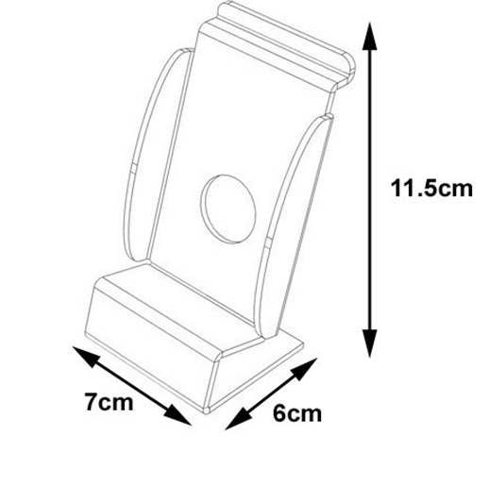  If working from home, remember to take a photograph of your work or attach a file in an email to your DT teacher to receive feedback. | Textiles Lesson 3
Drama | Home learning is available via SWAY. You must read the instructions very carefully and complete the escape room by completing a series of drama focused quizzes and puzzles. You begin at puzzle 1 and work your way through as and when you miss a drama lesson.  Send your escape room answers to stephanie.bottomley@appletonacademy.co.uk  If you have any questions or queries you can also contact Miss Bottomley on the above email address. | https://appletonrevision.weebly.com/ks3-drama.html | BTM
Music | You will access home learning via the SWAY. Read the instructions very carefully on what you must complete during any missed session. On the SWAY there is a link to a virtual practice room. This will guide you through practising a variety of pieces on a virtual keyboard.  You will send an overview and if possible, a recording of your rehearsed piece to stephanie.bottomley@appletonacademy.co.uk. You can also use this email address if you have any questions or queries. | https://appletonrevision.weebly.com/ks3-music.html | BTM
RE | Click the link and complete ‘WC 26th April ’.  Complete your work on a word document, or on paper.  Once you have finished, email your work to your RE teacher. | Year 7 lesson on Kant Ethics
PSHE | Please complete the work for the correct lesson.  if you have a 90 minute lesson, use the 90 minute lesson link; if it is 45 minutes, please use the 45 minute lesson link.  Email your completed work to your PSHCE teacher. | 90 minute lesson – Puberty  45 minute lesson – Personal Hygiene

