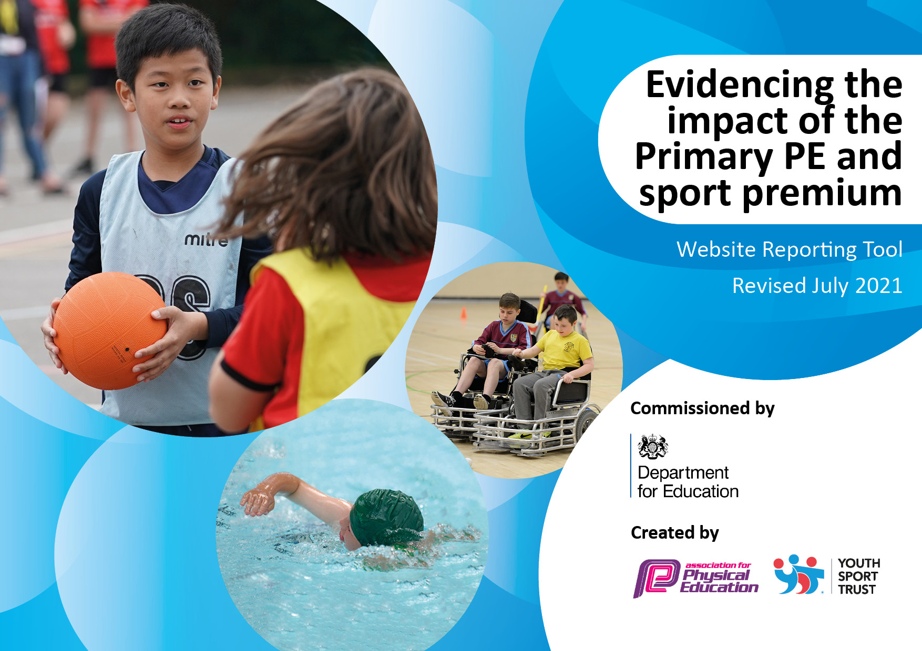
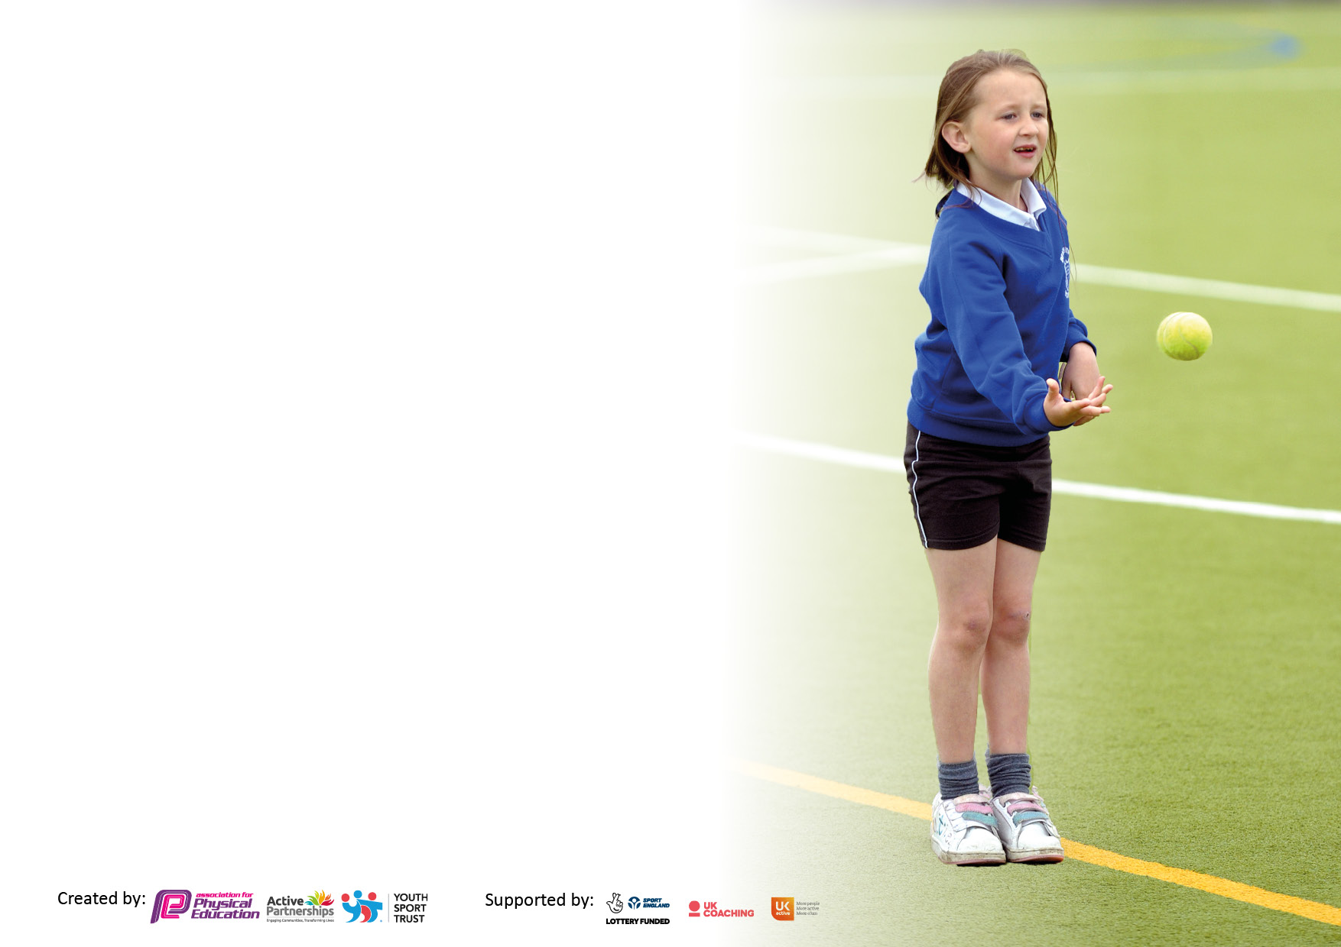

It is important that your grant is used effectively and based on school need. The Education Inspection Framework makes clear there will be a focus on ‘whether leaders and those responsible for governors all understand their respective roles and perform these in a way that enhances the effectiveness of the school’.

Under the Quality of Education Ofsted inspectors consider:
Intent - Curriculum design, coverage and appropriateness
Implementation - Curriculum delivery, Teaching (pedagogy) and Assessment
Impact - Attainment and progress

To assist schools with common transferable language this template has been developed to utilise the same three headings which should make your plans easily transferable between working documents.

Schools must use the funding to make additional and sustainable improvements to the quality of Physical Education, School Sport and Physical Activity (PESSPA) they offer. This means that you should use the Primary PE and sport premium to:

- Develop or add to the PESSPA activities that your school already offer
- Build capacity and capability within the school to ensure that improvements made now will benefit pupils joining the school in future years
- The Primary PE and sport premium should not be used to fund capital spend projects; the school’s budget should fund these.

Pleasevisitgov.ukfortherevisedDfEguidanceincludingthe5keyindicatorsacrosswhichschoolsshoulddemonstrate animprovement.Thisdocumentwillhelpyoutoreviewyourprovisionandtoreportyourspend.DfEencouragesschools to use this template as an effective way of meeting the reporting requirements of the Primary PE and sport premium.

We recommend you start by reflecting on the impact of current provision and reviewing the previous spend.

Schools are required to publish details of how they spend this funding, including any under-spend from 2019/2020, as well as on the impact it has on pupils’ PE and sport participation and attainment. All funding must be spent by 31st July 2022.

We recommend regularly updating the table and publishing it on your website throughout the year. This evidences your ongoing self-evaluation of how you are using the funding to secure maximum, sustainable impact. Final copy must be posted on your website by the end of the academic year and no later than the 31st July 2021. To see an example of how to complete the table please click HERE.

Details with regard to funding
Please complete the table below.

Total amount carried over from 2019/20 | £500.00
Total amount allocated for 2020/21 | £19,490
How much (if any) do you intend to carry over from this total fund into 2021/22? | £950
Total amount allocated for 2021/22 | £19, 470
Total amount of funding for 2021/22. To be spent and reported on by 31st July 2022. | £20,420
Swimming Data
Please report on your Swimming Data below.

Meeting national curriculum requirements for swimming and water safety.  N.B. Complete this section to your best ability. For example you might have practised safe self-rescue techniques on dry land which you can then transfer to the pool when school swimming restarts.  Due to exceptional circumstances priority should be given to ensuring that pupils can perform safe self rescue even if they do not fully meet the first two requirements of the NC programme of study | 70%
What percentage of your current Year 6 cohort swim competently, confidently and proficiently over a distance of at least 25 metres?  N.B. Even though your pupils may swim in another year please report on their attainment on leaving primary school at the end of the summer term 2020.  Please see note above | 60%
What percentage of your current Year 6 cohort use a range of strokes effectively [for example, front crawl, backstroke and breaststroke]?  Please see note above | 50%
What percentage of your current Year 6 cohort perform safe self-rescue in different water-based situations? | 50%
Schools can choose to use the Primary PE and sport premium to provide additional provision for swimming but this must be for activity over and above the national curriculum requirements. Have you used it in this way? | No

Action Plan and Budget Tracking
Capture your intended annual spend against the 5 key indicators. Clarify the success criteria and evidence of impact that you intend to measure to evaluate for pupils today and for the future.

Academic Year: 2020/21 | Total fund allocated:19490 | Date Updated: August 2021
Key indicator 1: The engagement of all pupils in regular physical activity – Chief Medical Officers guidelines recommend that primary school pupils undertake at least 30 minutes of physical activity a day in school |  |  |  | Percentage of total allocation:
 |  |  |  | %75
Intent | Implementation |  | Impact
Your school focus should be clear what you want the pupils to know and be able to do and about  what they need to learn and to  consolidate through practice: | Make sure your actions to achieve are linked to your intentions: | Funding allocated: | Evidence of impact: what do pupils now know and what can they now do? What has changed?: | Sustainability and suggested next steps:
Increase participation rates in physical activity at lunchtimes and playtimes whilst maintaining Covid safety measures.  Children to develop wider range of skills through the use of quality teaching resources and equipment.  All pupils and parents understanding the importance of physical activity and the importance of taking part in PE . | 2x sport coaches for lunchtimes.  Additional sports equipment for playground – ensuring each bubble has own set of equipment.  Purchase additional PE kits.  Training for lunchtime staff to develop activities at lunchtimes. | £14,500  £600  £100 | Sports coaches have worked with bubbles this year due to Covid and have delivered a wider range of physical activities due to additional resources purchased.  Additional PE and sports equipment purchased so that bubbles can have their own.  Children have been more active at breaks and lunchtimes with new resources. Additional space due to bubbles has led to wider range of games being played. Children have had more space to be active at breaks and lunchtimes. | Next steps  Potential purchase of Active English and Active maths.  New cover supervisors to take a lead at lunchtime and work with external PE provider to build on skills being taught in PE lessons.  New resources to be purchased for playtimes and lunchtimes to support with skills.  Development of playground will provide more opportunities for physical activity.  Additional CPD for new lunchtime supervisors.
Key indicator 2: The profile of PESSPA being raised across the school as a tool for whole school improvement |  |  |  | Percentage of total allocation:
 |  |  |  | %6
Intent | Implementation |  | Impact
Your school focus should be clear what you want the pupils to know and be able to do and about  what they need to learn and to  consolidate through practice: | Make sure your actions to achieve are linked to your intentions: | Funding allocated: | Evidence of impact: what do pupils now know and what can they now do? What has changed?: | Sustainability and suggested next steps:
Continue to raise the profile of school sport and the wide range of skills that are learnt.  To ensure the PE co-ordinator is highly skilled and pro-active in raising attainment.  To ensure that achievement in sport and PE is recognised and celebrated.  To ensure that equality and diversity is recognised and celebrated in sport. | Achievement in PE to be celebrated in achievement assemblies/ class assemblies. Development of sports star of the week for display in the classrooms while restrictions are in place.  Release time for PE co-ordinator to attend appropriate CPD, liaise with other co-ordinators (remotely), release time to conduct joint observations. | £1000 | Sports star of the week celebrated with classes and on weekly primary newsletter. Display updated weekly and in classrooms.  PE co-ordinator has had time with sports coach to review long term plans and adapt these as necessary in the light of covid.  Profile of sports raised through celebrations and through Olympic themed week and visitors to school.  Children have a wider knowledge of sports clubs available to them. Local rugby team informed school that they had an immediate increase in numbers after delivering taster sessions at school.  Through the use of visitors children are more knowledgeable about the wider impact of taking part in sports and physical activity. E.g. benefits to mental health. | Next steps  New PE co-ordinator in place for September – time needed to work with SLT on PE planning and to liaise with new sports coach.  Calendar of visitors to be developed.  A celebratory week of sports to be planned each year.  Children to be encouraged to bring in achievements from outside school from clubs they attend.  PSHE curriculum to further develop children’s understanding of how physical activity and being part of a team can benefit mental health.

Key indicator 3: Increased confidence, knowledge and skills of all staff in teaching PE and sport |  |  |  | Percentage of total allocation:
 |  |  |  | %6
Intent | Implementation |  | Impact
Your school focus should be clear | Make sure your actions to | Funding | Evidence of impact: what do | Sustainability and suggested
what you want the pupils to know | achieve are linked to your | allocated: | pupils now know and what | next steps:
and be able to do and about | intentions: |  | can they now do? What has
what they need to learn and to |  |  | changed?:
consolidate through practice:
To ensure all teaching staff are skilled in the delivery of sports in school.  PE specialist to provide CPD for primary staff. | Timetable for staff release.  Cover needed for staff observing and working with specialist.  Training for lunchtime staff to take place to develop knowledge of games that can be delivered. | £1000 | Staff have had opportunity to observe PE specialist and develop their knowledge.  Training for lunchtime staff unable to take place due to Covid restrictions. | Next steps  Continue CPD for new staff  Training for lunchtime staff to continue.
Key indicator 4: Broader experience of a range of sports and activities offered to all pupils |  |  |  | Percentage of total allocation:
 |  |  |  | 8%
Intent | Implementation |  | Impact
Your school focus should be clear | Make sure your actions to | Funding | Evidence of impact: what do | Sustainability and suggested
what you want the pupils to know | achieve are linked to your | allocated: | pupils now know and what | next steps:
and be able to do and about | intentions: |  | can they now do? What has
what they need to learn and to |  |  | changed?:
consolidate through practice:
Increase the attendance of children at sports clubs both within school and outside of school.  Expand number and variety of sports clubs. | Continue to work with coaches to ensure high quality clubs. Monitor uptake and promote to ensure all places are taken and that wide range of children are accessing these (particularly PPG and SEND who are not accessing clubs outside of school).  Children in KS2 to have further opportunity to develop ‘play leader’ skills within their year groups in the first instance. Coach currently working in school to develop new play leaders.  Continue to promote external clubs through demonstrations in assemblies etc.  Wider use of school sports facilities for clubs when safe to do so. | £1500 | External clubs promoted across the year with visitors in school leading to increased numbers attending.  All children received rugby coaching from local rugby club coaches.  Wide range of visitors in school has challenged children’s perceptions regarding gender and ability in taking part in sports.  OAA taken place for Y6 including use of trampolines, climbing wall.  Children in Y6 have received training in play leaders – due to Covid restrictions they have been unable to deliver this beyond their bubble. | Next steps  Wider range of enrichment to be offered both within school day and after school.  PE specialist / cover supervisors to deliver play leader training  PE co-ordinator to develop calendar of sports providers to visit school/ deliver sessions  New OAA staff to deliver timetable of OAA activities to all primary across the year.

Key indicator 5: Increased participation in competitive sport |  |  |  | Percentage of total allocation:
 |  |  |  | %6
Intent | Implementation |  | Impact
Your school focus should be clear | Make sure your actions to | Funding | Evidence of impact: what do | Sustainability and suggested
what you want the pupils to know | achieve are linked to your | allocated: | pupils now know and what | next steps:
and be able to do and about | intentions: |  | can they now do? What has
what they need to learn and to |  |  | changed?:
consolidate through practice:
Children to take part in a range of competitive sports.  School to take part in inter-school competitions with local area primaries, schools within the Trust or wider festivals. | PE co-ordinator to develop calendar of competitive sports.  PE co-ordinator to liaise with sports coach to ensure close links with PE curriculum to enable children to put skills in to practise.  Inter-bubble competitions to take place across the year during restrictions.  PE co-ordinator to liaise with Sports UK and LAP/ Trust schools to organise competitions.  Cover to be arranged for PE co-ordinator.  Transport to be arranged for children to attend competitions.  Purchase kit and medals. | £1000 | External competitions unable to take place due to Covid restrictions.  Competitive sports have taken place within classes and year group bubbles.  Medals and rewards purchased. | Next steps  Develop calendar of competitive sports with LAP, Trust schools and festivals.

Signed off by
Head Teacher:
Date:
Subject Leader:
Date:
Governor:
Date:

